PART THREE
10
Diagnosis and treatment of postural disorders

CHAPTER
Hydrotherapy in the treatment of postural disorders

250 Adapted water activity for postural disorders

254 Principles for planning a hydrotherapy program for children with postural disorders

257 Summary

Hydrotherapy is rapidly gaining acceptance today as a physical therapy and rehabilitation treatment. The main reason for its popularity lies in the special qualities of water (buoyancy, resistance, and heat) (Bergman & Hutzler, 1996). This chapter will discuss several therapeutic beneﬁts of activity in water, and will also mention contraindications in the therapy process.
In this vein, it is worth re-examining the almost universal dictum that “swimming is a healthy activity”. This belief tends to ignore the swimmer’s limitations and the risks the activity entails.

Swimming is not necessarily healthy and in terms of treatment, if it is not adapted to patient’s special needs, it may even be harmful (Solberg, 1995).
CHAPTER 10
Often, orthopedists refer children for therapy in words to this effect: “The above patient has a postural disorder – swimming is recommended.” This recommendation usually does not include any reference to the essence of the disorder any contraindications in treating it. According to this approach, anyone who passes a short basic swimming course can act as a hydrotherapist for children with postural disorders. However, treating these children is a complex process because of the
limitless variations these disorders can assume. Therapists must deal with the complexity of the problem, and on the basis of an initial diagnosis, construct an activity program adapted speciﬁcally to the children’s needs. This process requires much more than learning how to swim, and therefore by its very deﬁnition, the therapeutic technique is not “swimming” but “water adapted activity”. According to this model, it may very well be that therapists choose to teach children a special swim style that does not appear in any conventional book on learning to swim.

The following are examples of a few disorders that require extra caution when using hydrotherapy

- In treating lordosis, the breaststroke is contraindicated because of
the tendency to increase lumbar lordosis in the swimming movement (Fig. 10.1). This swimming style is also not recommended in cases
of excessive cervical lordosis, heightened muscle tone in the erector spinae of the cervical spine, and structural pathologies such as spondylolysis and spondylolisthesis
- In treating scoliosis, the swimming style must be speciﬁcally adapted to the direction of the spinal deviation. This requires great expertise and must be done only by professionals in the ﬁeld. If therapists choose to use only symmetrical movements (for overall physical exercise), it is recommended to concentrate on the classic backstroke
- In cases of disorders of the hip, knee and ankle joints, therapists must also take the diagnostic data into consideration (see Ch. 5). For example, the breast stroke is recommended for treating medial rotation of the lower extremities because it encourages the opposite movement (lateral rotation) in the hip joints. In the opposite condition, where the problem is characterized by a toe-out position, the freestyle (crawl) is recommended because it encourages medial rotation of the legs
- In certain conditions, such as Marfan’s syndrome, which is characterized by over-ﬂexibility of the joints, patients should be assigned a personal style that integrates arm movements
characteristic of the breaststroke style and leg movements typical of the crawl. In this case, the regulation breaststroke is contraindicated because it increases ranges of hip joint movement and creates unwanted tension in the medial aspect of the knee joints (Fig. 10.1). Ignoring this information will cause the patient more harm than good.
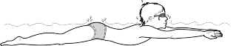
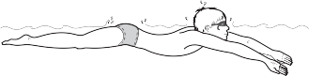
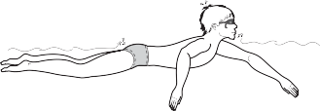
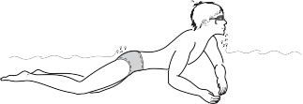
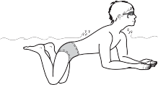
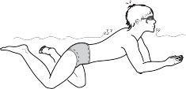

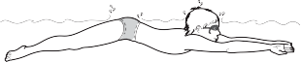

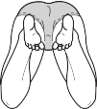

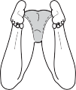

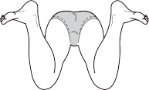

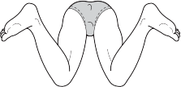

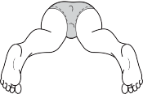

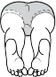

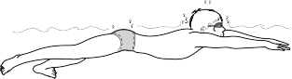

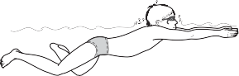
Figure 10.1 Swimming the breaststroke: Posterior and lateral views.

As these examples indicate, in treating postural disorders, swimming alone is not enough. Attention must be paid to information about the problem in order to determine the proper type of activity. Only in this way can treatment engender real improvement and even more importantly, avoid injury. Swimming has many beneﬁts, but therapists must try to avoid adopting prepackaged programs that appear in the literature, and use their professional discretion in the therapeutic process.

Adapted water activity for postural disorders

In terms of indications for using hydrotherapy for postural disorders, a clear distinction should be made between physical medical indications and therapeutic sport indications (Snir, 1996).

Medical indications

Because of the special qualities of water, hydrotherapy is especially suitable for conditions that are vulnerable to injury from weight-bearing loads, such as idiopathic scoliosis, rehabilitation after back surgery, etc. In such cases, water increases relaxation, maintains – and even increases
– ranges of joint motion, and when needed, strengthens various muscles without creating vertical loads on body joints, especially on the spinal column.
Many postural disorders are characterized by heightened muscle tone with resulting movement restrictions. Water (at a comfortable temperature) may help to bring the muscular system to a state of relaxation, and thus encourage freer movement of the problematic area. Relaxation of this type can help children to attain normal muscle tone, and encourage broader ranges of motion. In general, the ability to relax combined with reduced effects of gravity improve movement potential in cases of children with a variety of disabilities, among them postural disorders.

Therapeutic sport indications

Water activity adheres to the principles of therapeutic sport. Special emphasis is placed on the gradual transition from “exercises” deﬁned as the “therapeutic component” to active physical and recreational activity (learning to swim).

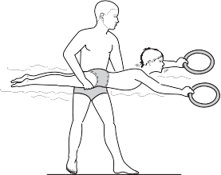

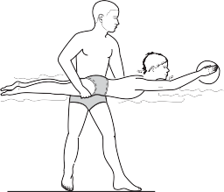
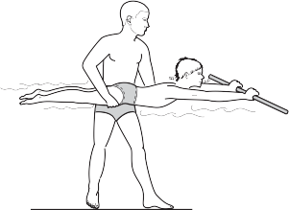
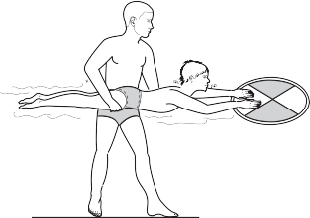
Figure 10.2 Use of various types of apparatus in water activities.

In planning a therapy and rehabilitation program in water, a number of factors should be kept in mind (Bergman & Hutzler, 1996):

- Water depth: Buoyancy support increases as large parts of the body are submerged in water, therefore it is recommended to execute some of the exercises for the lower part of the body in deeper water ﬁrst and then progress gradually to shallow water. On the other hand, maximal resistance will be attained when the entire body is submerged in water, which is important when performing exercises to strengthen the upper part of the body and upper extremities
- Movement speed and range of motion: Movement speed has
a signiﬁcant effect on water resistance: a small increase in speed increases resistance considerably. Similarly, increasing patients’ range of motion also raises the level of difﬁculty. For these reasons,
it is advisable that patients begin activities slowly and with a small range of motion, then gradually increase both speed and range. Usually improper movement patterns indicate that patients are working beyond their ability in terms of range of motion or speed
- Patients’ position: Patients’ positions during their water activity should be determined by diagnostic results and by the characteristics of the disorder. Activity may include a variety of starting positions such as sitting, standing, lying face down, lying on back, etc. Each position has kinesiological implications for the musculoskeletal system,
which is why it is important to adapt the recommended swimming style to the various postural disorders
- Closed kinematic chain and open kinematic chain: In designing
a hydrotherapy program, it is possible to control the intensity of the gravity load using buoyancy as a resistive force. A joint that moves against a constant resistance source, such as the ground, creates a closed kinematic chain. In this way, exercises performed while standing in shallow water are usually similar to closed kinematic chain exercises, even though the load on the joint is smaller (than on land) because of the opposing force of buoyancy. On the other hand, exercises in deep water are usually referred to as open kinematic chain exercises – exercises that are performed horizontally (like swimming). Various resistive apparatus tend
to “close” a kinematic chain.



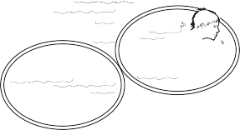
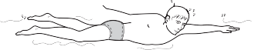
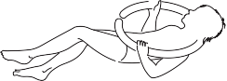
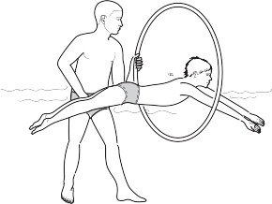
Figure 10.2 (continued).

The decision whether to use closed or open kinematic chain exercises is left to the discretion of the therapists, who should base their decisions on the nature of the problem and the aims of the therapy.
Water activity as a means of therapeutic intervention for postural disorders concentrates on a number of major aspects (Solberg, 1995) as noted below.

Work on body awareness and body image
How people refer to the world around them depends on their body image. If they are not completely aware of their bodies, any action requiring such awareness will be ﬂawed. Perceptions of the “self” are embedded in relationships with self and general spatial orientation, where the central reference point is the body. Many children with postural disorders have difﬁculty in this respect because of various asymmetries in their body position, and therefore, among other things, their movement learning is imperfect and they adopt erroneous movement patterns. Activity in water allows patients to experience new movement options, and exercising in self- and general spatial orientation in water also contributes to enhancing body awareness.
Apparatus such as skip ropes, hoops and balls are possible aids that allow children to raise their awareness about their own body and objects around them (Fig. 10.2). This aspect is especially important in cases of “new” limitations, such as injuries to the spinal column and physical disabilities resulting from accidents.

Improving general body system functioning
- Respiratory system: The very act of being submerged in the water entails constant pressure on the chest and lungs, which has a positive effect on respiratory system functioning. Water activity raises patients’ awareness of the breathing process, including its rhythm and duration (Bergman & Hutzler, 1996). Furthermore, water activity also facilitates work to improve cardiopulmonary endurance (by means of endurance exercises in water).
- Improving ranges of joint motion by active and passive stretches: This is important mainly in cases of orthopedic problems (before and after surgery). Water activity may help patients to return to regular independent functioning.
- Improving muscle strength and endurance is also an important component for improving functioning. Water creates resistance to active movement on all planes, and thus facilitates exercise and practice for muscles and joints in a wide array of implementation angles. Exercise can be performed in movements involving the entire body (swimming, walking) or movements isolating speciﬁc limbs by holding onto the wall for support (Bergman & Hutzler, 1996).
- Neuromuscular functioning, mainly for improving coordination and balance: Water activity offers an array of means of working on disabilities characteristic of many postural disorders. The advantage of water activity in these cases lies in the slowing down of various movement stages (because of water resistance), thus producing highly effective “learning conditions”.

Coordination problems and difﬁculties in maintaining balance can be treated in water by practicing variations of transitions from one physical position to another, changing movement direction, changing rhythm (slow, fast, stop), changing style while advancing, etc. Such exercising will also affect patients’ awareness of the kinesthetic feedback they receive during the activity.

These are some examples of exercises for improving balance

- Transition from standing in water to ﬂoating on stomach and back to standing
- Transition from ﬂoating on stomach to ﬂoating on back
- Advancing while swimming the sidestroke and changing the direction of movement from side to side
- Swimming in circles from right to left
- Swimming a “slalom” between ﬂoats
- Swimming forward, stopping in place and swimming backward
- Regular walking in water
- Walking on toes
- Walking on heels
- Walking heel to toe
- Walking sideways – to the right and to the left
- Moving forward in two-leg jumps in shallow water
- Moving forward in one-leg hops in shallow water
- “Stepping leaps” with arm–leg coordination, in water at hip or chest height
- Standing in place on one leg and maintaining body balance using arm motions (therapists can “stir up” the water around the patients and create waves to raise the level of difﬁculty for maintaining body balance).

Exercises of this sort have many possible variations. Over time, training will lead to better mastery of the transitions between body positions and to improved balance ability, coordination and body organization in both personal and general space. This improvement may also be reﬂected in the children’s functioning outside of water.

Improvement in affective (emotional) functioning
Activity offering pleasure and a feeling of “success” is highly important for children with disabilities (both affective and physical). Water activity allows children with physical disabilities to shed all the auxiliary aids they need for regular land-based activity (walkers, support braces for the spine, etc.) and to behave freely in the water. The new physical abilities they reveal in the water will be an experience of success and satisfaction that will reinforce their self conﬁdence and self esteem.

Principles for planning a hydrotherapy program for children with postural disorders

Hydrotherapy as a means for treating kyphosis

Exercises to improve mobility of thoracic vertebrae

Strengthening of upper back muscles and scapular adductors

Flexibility exercises for the pectoral muscles

Aerobic activity for improving cardiopulmonary endurance


Exercises to improve respiratory ranges

Figure 10.3 Main aspects of hydrotherapeutic treatment of kyphosis.
The principles presented here are based on additional aspects that are detailed in Chapter 14. Building a therapeutic program must personally suit the children’s needs as determined by an initial diagnosis that includes cognitive, affective, social, and physical condition, as well as motor abilities in water and outside it (see Ch. 7).

- Each meeting should include two components:
- A therapeutic component – speciﬁc exercises for the type of problem or disability (exercises for strength and ﬂexibility, different manners of advancing in water, breathing exercises, etc.).
- Play and enjoyment – this will enhance motivation, perseverance and patient–therapist ties (ball games, use of various apparatus, diving games, etc.). In this model, the initial activity emphasis is on the affective side. Safe and enjoyable activity in this domain will usually heighten motivation and prepare the groundwork for success in future treatment.
- Every few months it is advisable to conduct comprehensive postural tests outside of the water to monitor progress and to set treatment aims for continuation. It should be remembered that in most cases, postural disorders are dynamic. They may improve or they may worsen, but they usually do not remain unchanged. Therapists must be aware of these changes and adapt themselves to the children's condition.

To illustrate what has been presented up to this point, the following therapeutic program is presented as an example of dealing with kyphosis, a common postural disorder.

Treating kyphosis

Main aspects of the disorder
Kyphosis is marked by an exaggerated arch in the thoracic vertebrae and a tendency of the shoulders and head to tilt forward (see Ch. 3). Other common characteristics are possible shortening of the pectoral muscles, weakness in the upper back area and sometimes increased cervical lordosis. Breathing may also be short and shallow, and body awareness weak.
In light of the above, hydrotherapy treatment should concentrate on a number of aspects (Fig. 10.3):

- Exercises to stretch and lengthen pectoral muscles
- Strengthening upper back muscles, mainly the scapular adductors
- Breathing exercise to increase range of respiration (mainly inhalation)
- Aerobic activity to improve cardiopulmonary endurance
- Practice to improve thoracic vertebrae mobility (T1–T12)
- Awareness and relaxation exercises.

Recommended exercises for kyphosis
The list of exercises proposed here is an example of gradual training in water for meeting special needs:

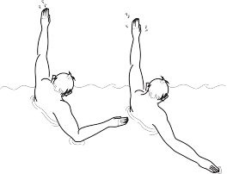
- Standing in water up to shoulder height – actively stretching arms with circular movements up and backward.

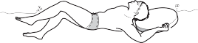
- Therapist executes passive stretches while patient lies motionless
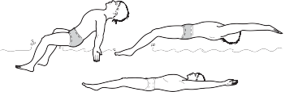
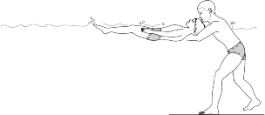
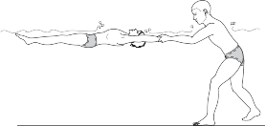
on back, arms straight and stretched backward (behind the head).
- Lying on the back holding a board with arms straight backwards – making leg
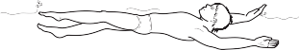
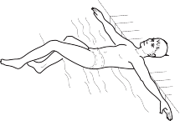
movements as in breaststroke or crawl; maintaining straight body position without raising head forward (and making sure pelvis does not sink).

- Back push off – holding side
of pool with hands and pushing back hard while stretching the body.
- Holding side of pool with both stretched hands, back to wall and doing cycling movements with legs
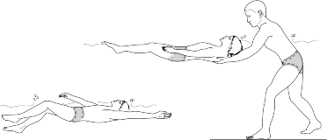
(when performed for extended periods this is also an endurance exercise that also stretches pectoral muscles with arms to the sides).

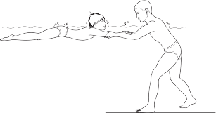
- Swimming in the classical backstroke style – circular arm movements near the center of body

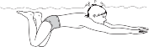

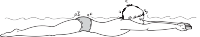

- Back crawl – full movement with arms straight, near central axis of body. Occasionally therapist should provide support between the scapulae.

- Forward gliding – pushing the wall with legs and stretching arms forward while lowering head and exhaling in the water.
- Lying ﬂoating on the stomach, arms straight and supported by the therapist
– legs kicking as in the crawl style combined with exhaling in the water.

Figure 10.4 Recommended exercises for kyphosis.

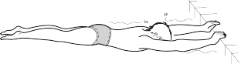


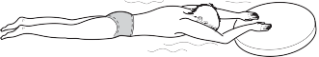
- Floating on the stomach, hands straight forward and grasping the rim of the pool – legs kicking as in the crawl while exhaling in the water.

- Swimming on the stomach while holding a board with body straight and tensed – legs movement as in breaststroke or crawl.

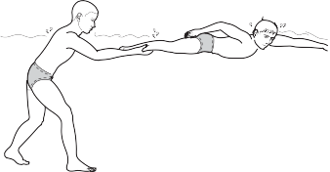
- Swimming the freestyle (crawl) with the therapist holding the patient’s legs under water and creating light resistance.

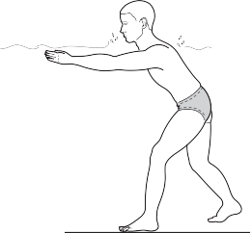


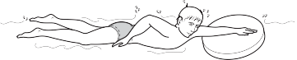
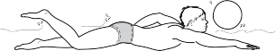
- Swimming freestyle with one hand, while the other is holding a ﬂoat board.

- Pushing a ball while swimming the crawl.
- Walking forward in water up to the shoulders while strongly pulling the water from front backwards without removing arms from the water.

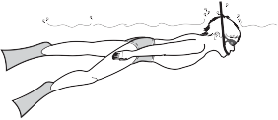

- Practicing breathing in the water using a snorkel and ﬁns.

18. Passing a ball – in deep water.


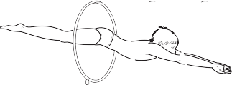
- Diving from a sitting position on the pool lip, passing through hoops weighted in the water.

- Relaxing while ﬂoating on the back, taking deep breaths – with therapist supporting the body.

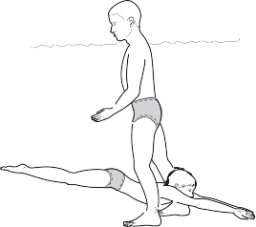

- Gliding down from a sitting position on the pool lip into the water and passing through the therapist’s legs.

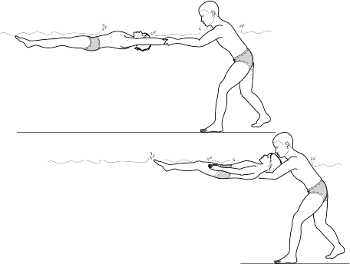
Figure 10.4 (continued).

The exercises presented in this program are for illustration only, and can be adapted, developed and altered as long as water safety rules and accepted kinesiological principles are adhered to. At the same time, as mentioned, an important part of treating postural disorders entails changing existing movement patterns and intensive work on body awareness. For this reason, it is recommended to integrate water activity with regular remedial exercise outside the water, to attain optimal results.

Summary

One of the main aims of this chapter is to encourage therapists to use their discretion in choosing rehabilitative activity in water. To this end, several main aspects have been reviewed, including the advantages of water activity as a therapeutic intervention for postural problems and the principles for building a hydrotherapy treatment program.
Postural disorders are complex, as is the nature of the treatment planned for each problem. Treatment of kyphosis, as presented in this chapter, is a speciﬁc example of how to construct an activity program for postural disorders.

PART THREE
11
Diagnosis and treatment of postural disorders

CHAPTER
Auxiliary equipment for adapted physical activity

260 Creative use of equipment in treatment

- The “underlying abilities” model

- The “working on the whole” model
CHAPTER 11

In order to design a therapeutic program properly, therapists must understand the nature of the disorder they are treating and correctly analyze the functional–motor difﬁculties it engenders. This is the basis on which therapists should introduce varied and interesting activities to improve these functions.
This chapter will deal with ways of creatively using auxiliary aids during the treatment of postural disorders on the assumption that the proper use of apparatus and equipment may help to stimulate cognitive, affective, and physical developmental processes.

Creative use of equipment in treatment

Over the years, the ability of children to plan or create organized patterns progresses along a movement continuum. Improvement on this continuum can be observed in their expanding repertoire of physical abilities and in their normal movement and postural patterns.
Maturation of the central nervous system is a prerequisite for normal functioning, but rich motor exposure and appropriate practice also play an important role in the process of acquiring a wide array of skills.
Numerous models have been developed for the improvement of motor functioning. The comprehensive treatment approach advocated in this book relies on two eminent models.

The “underlying abilities” model

According to the underlying abilities approach, basic motor abilities are an indispensable prerequisite for success in various skills of daily functioning; for example, coordination and balance are the basis for normal walking. These abilities are indispensable for optimal func- tioning. Moreover, they are included or integrated in the required skill and therefore treatment techniques that make use of this model emphasize work on movement components.

The “working on the whole” model

This therapeutic model, in contrast, is based on the idea that treatment should emphasize activities that include the underlying abilities, and not work on developing them separately. In other words, even though the underlying abilities are included and integrated in the required skills, there is also a reverse effect – when the whole skill is activated, underlying abilities will necessarily be involved in them. Therefore, according to this approach, full activation of the inclusive whole will contribute to the improvement of the components.
This would seem to be one of the differences between the adapted physical activity approach and other treatment techniques. While in paramedical treatment therapists usually emphasize working on posture components (speciﬁc exercises for stretching and strengthening muscles); the adapted physical activity approach also emphasizes work on whole skills as a means of treating these components.
The learning process in this approach is active. For example, if the therapist wants a child to perform elbow extension, it is possible to design a task such as hammering a nail or shooting a ball at a basket. After the child has performed arm extension, the therapist can call his attention to the desired result (extension of the elbow joint) so that the child can implement it in other situations as well (transference).
The recommended way of treating children with postural disorders combines both models.
Another important aspect of this integrative approach is the child’s enjoyment of the treatment process. Success and an enjoyable feeling in the activities constitute important bases for motivating children to continue working. The basic assumption is that if children enjoy an activity, they will be more motivated to carry on with it and make the effort it requires of them. This means that one of the important challenges facing therapists is ﬁnding ways to activate children in a manner that appeals to their interests and personality and that are, at the same time, relevant to the treatment aims.
An example illustrating this approach entails two types of exercises for strengthening back muscles (see Fig. 11.1).

Both exercises are equally effective in attaining the goal – strengthening the back muscles – but they differ in both manner and approach. In Exercise A, the patient concentrates on the effort and at times performs the exercise with a feeling of discomfort mixed with boredom. In Exercise B, in contrast, the child is given an interesting and challenging task that both helps to strengthen the back and impart a feeling of enjoyment. In this situation, the child will concentrate less on the difﬁculty and effort, and more on the experience itself.
As noted, it is recommended to use both methods, that is, “sterile” more precise drills together with tasks that utilize adapted apparatus and place greater emphasis on the children’s interests, motivation, consideration of their personality, and materials that appeal to them (see Fig. 11.2).


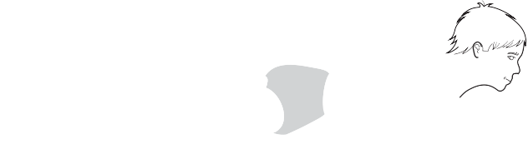
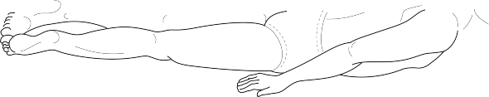

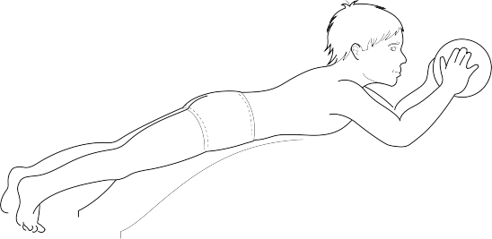
A

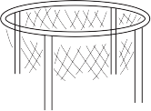

B

Figure 11.1 (A,B) Exercises to strengthen back muscles.

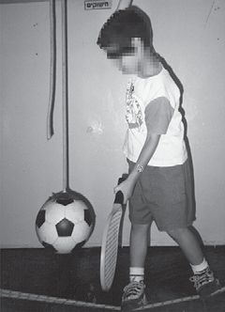

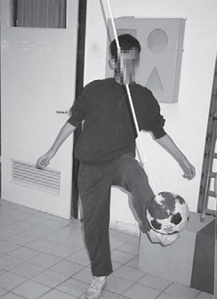
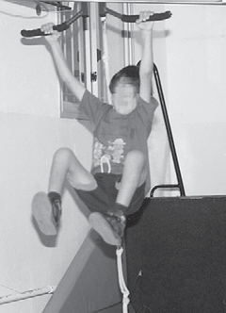
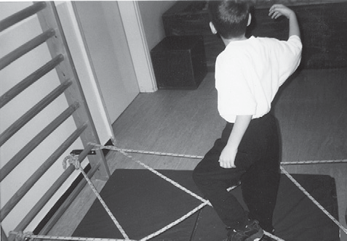
Differentiation of movement and regulation of force using hanging ropes and racquet.
Working with an omega. Kicking a hanging ball
for work on timing and coordination.
Going through an obstacle course to improve movement planning and spatial orientation.

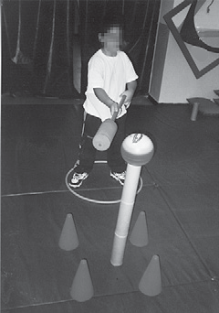

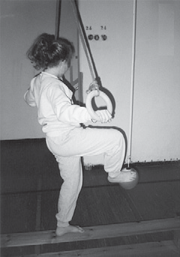
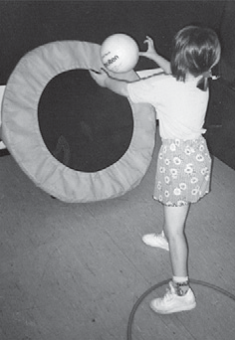
Crossing the midline and visuomotor coordination with pillow-polo poles.

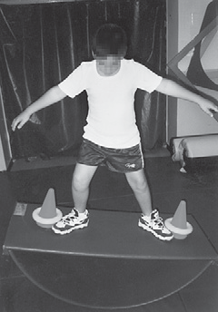
Exercise in passing and catching using a trampoline and ball.

Static balance and movement timing on a bench.

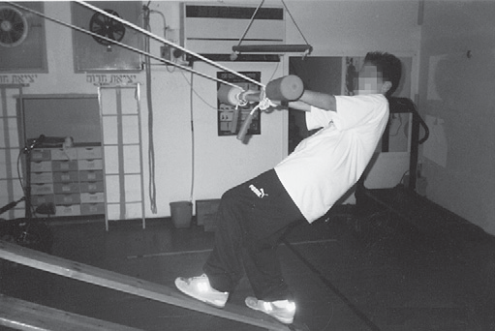
Simulation of surﬁng using an inclined bench.

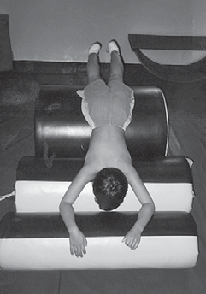

Passive movement on three inclined rollers.

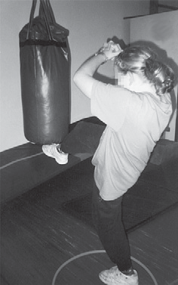

Kicking a punching bag to improve balance and coordination

Balance exercise on rolling surface.

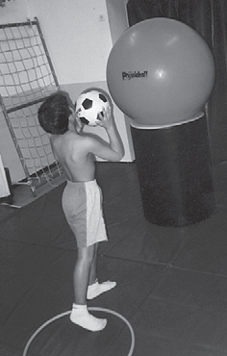

Practicing passing and catching using a
physiotherapy ball and roll.

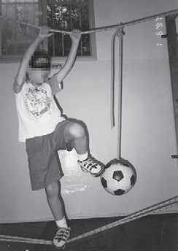
Improving racquet skills with hanging ball.

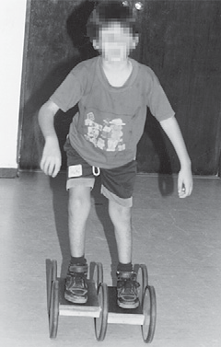

Riding a Pedalo to improve motor control and balance.

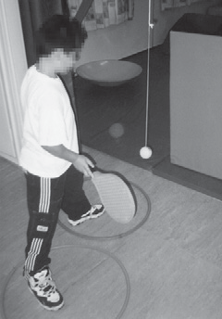
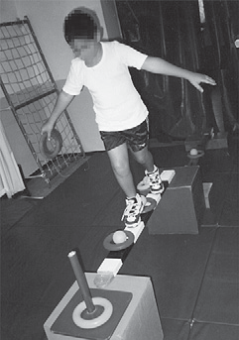
Static and dynamic balance on a balance bar.

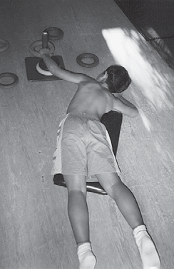

Strengthening back and shoulder girdle in activity with scooter.

Body organization with hanging ropes and ball.

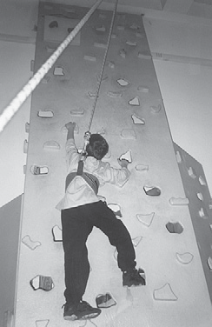

Climbing wall to nurture self conﬁdence and work on movement planning.

Figure 11.2 Adapted use of equipment during treatment.

PART THREE
Diagnosis and treatment of postural disorders

CHAPTER
Movement and postural
development in early childhood: principles and applications

266 Common developmental characteristics of early childhood

270 Orthopedic aspects and common postural disorders in early childhood: diagnosis, prevention, and treatment

273 Summary
12

The ﬁrst years of children’s lives are marked by changes in motor and physical development. The movement activity to which children are exposed during these years plays a predominant role in shaping their abilities in the future. Children observe their limbs, feel them and move them in their personal and general space. As mastery of their body becomes more reﬁned, their increasing motor control allows them to gradually acquire skills such as grasping, throwing and catching a ball, passing a ball, crawling and walking, by using the developing abilities of balance, coordination, regulation of force, kinesthesis, etc.
The many movements that children attempt make them function more efﬁciently and improve their ability to plan and differentiate movements,

perceive direction and develop spatial orientation. All of these skills contribute to molding the children’s posture and facilitating their normal physical development.
CHAPTER 12
However, a lack of awareness of these skills may impair children’s movement and posture development. Many children who do not receive sufﬁcient exposure to movement activity experience difﬁculties stemming from motor deﬁciencies. In other cases, various posture disorders develop because the children remain in certain body positions for long periods of time or have faulty movement habits.
Normal development in children is a mix of both genetic inherited and environmental factors. Despite signiﬁcant genetic effects on children’s posture and development, environmental elements are also of
great signiﬁcance. Parents and professionals who come in contact with children in early childhood should be keenly aware that all issues pertaining to physical activity may be important for optimal development.
Such awareness naturally raises questions:

- Should an infant sleep on the back or the belly?
- How should children be encouraged to sit?
- Should children be helped in walking or should they attempt it themselves?
- How can children be activated so as to improve their overall physical strength?
This chapter will survey important aspects of movement and postural development in early childhood as a means of preventing, as much as possible, the appearance of disorders at a later age.

Common developmental characteristics of early childhood

Birth–2 years old

This period is characterized by continuous development from reﬂexive involuntary activity to more controlled and organized movement. Infant motor development includes several milestones, such as head-raising, turning over, crawling, sitting, standing and walking.
These stages of infant motor development during the ﬁrst year con- tribute both to posture (general strengthening and gradual development of the spinal curves), and to motor abilities (gross motor development as well as providing an important functional basis for ﬁne motor activity). Basic motor patterns appear during the initial developmental period in a deﬁned and predictable sequence. Keeping this in mind, it is important to review a number of universal principles of motor development which become evident in some common patterns (Yazdi-Ugav, 1995).

Cephalocaudal direction
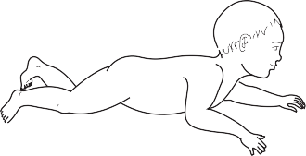
Gross motor development begins from the top down, towards the legs. In this process, motor control and mastery develop and take shape ﬁrst in the head area (strength of the neck muscles), then moves down to the upper torso and upper extremities, and gradually reaches the lower torso and lower extremities (Yazdi-Ugav, 1995).
In this way, infants experience a number of developmental milestones, such as raising their head while lying on their belly, rising to a leaning position on forearms and elbows, sitting, crawling, standing and walking (Fig. 12.1).
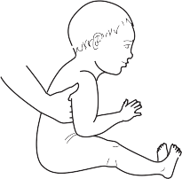
Incomplete patterns of cephalocaudal direction may be reﬂected in developmental retardation, and later in heavy and clumsy movements.

Proximal–distal coordination

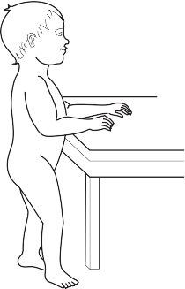
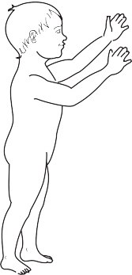
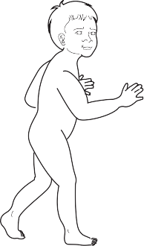
The muscles closer to the midline of the body become functionally capable in terms of coordination and motor control faster than the muscles further away from the midline. This developmental pattern

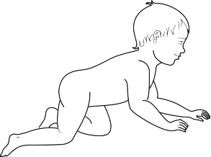

Figure 12.1 Milestones in motor development: First year.

underlines the functional ties between gross and ﬁne motor activity where, for example, the strength of the large muscle groups in the shoulder girdle provides the stability necessary for the hands and ﬁngers to perform the ﬁne motor manipulations required for writing, cutting, buttoning, etc.
What these facts emphasize is the body’s need for activity to strengthen large muscle groups that contribute to body stability in daily functioning.

Motor behavior is affected by the infant’s neurological functioning
Neural development is reﬂected in progress from simple, massive and reﬂexive movements to ﬁne, integrative movement.
Many of the reﬂexive movements that develop after birth serve as the basis for the development of movement patterns that are later controlled by the higher control centers in the brain (Yazdi-Ugav, 1995). It should be remembered that motor development is dependent in great part on the rate of the infant’s neurological maturation, and this process cannot by hastened by speciﬁc training.
Attempts to speed up natural processes may also cause damage. For example, encouraging children to stand or walk before these activities occur naturally can create overload on the hip or knee joints and impair optimal development (the “ﬁrst child syndrome”).
At the same time, although some of the infant’s neuromuscular responses are reﬂexive in nature, most are voluntary and learned, and inﬂuenced by environmental factors and previous experience. Thus, as infants progress in their physical development, the ratio between involuntary and voluntary responses is modiﬁed, as reﬂexes slowly disappear, and controlled coordinative movements develop.
This accounts for the importance of exposing children to rich motor stimulation (by forming a stimulating environment) that encourages them to act, strengthens them and also ensures that they will not be deﬁcient in the array of movements in their arsenal. Apart from improving children’s movement patterns, this approach may also have a positive emotional side-effect of improving their self conﬁdence and self esteem (Fig. 12.2).

Ages 2–4

This period in children’s lives is characterized by the reﬁnement of existing motor functions, together with the acquisition of new skills such as running, climbing, and jumping. Fine motor coordination also improves gradually, allowing children to better control their movements, even the ﬁne movements performed by small muscle groups.
Physically, this is a stage of constant physical body growth. Skeletal growth is relatively fast, and the bones are mainly cartilaginous and soft. Muscular system development is concentrated predominantly in the large muscle groups, and the spinal curves continue to develop slowly.
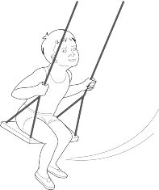
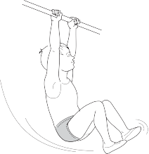

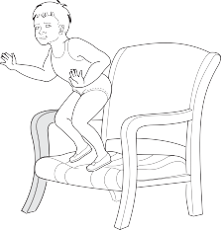
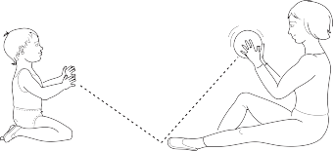

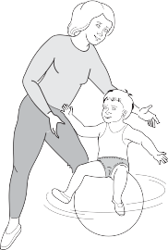
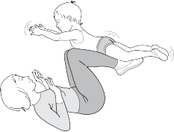

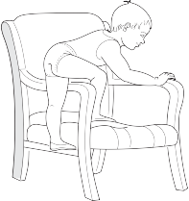
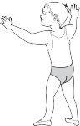
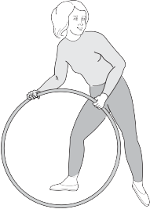
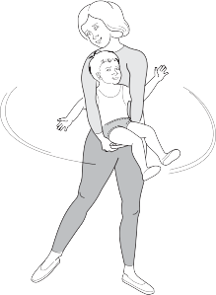
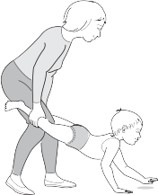

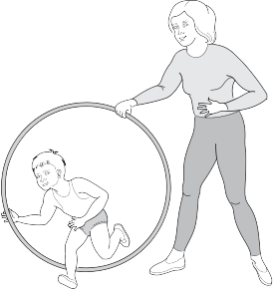

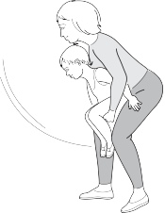

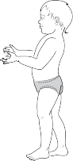

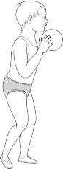
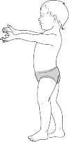
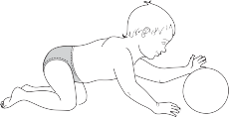
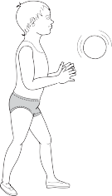
Figure 12.2 Psychomotor exposure during various developmental periods of early childhood. The emphasis in the examples presented is on simple and available motor activities that can be performed in the family setting (home, yard, or playground), and which may contribute to the child’s normal development both physically and emotionally. The emphasis in these activities is more on motor experience and pleasure, and less on the ﬁnal results of the movement.

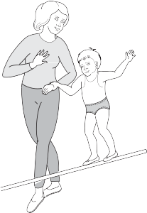
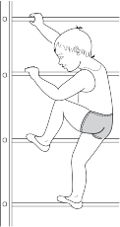
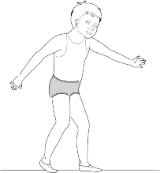

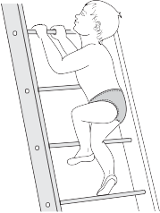
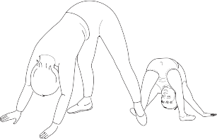
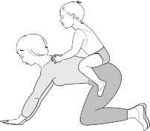
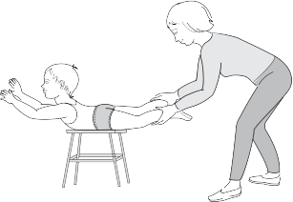

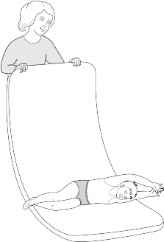

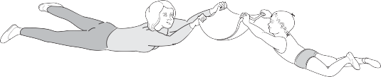

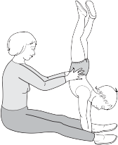

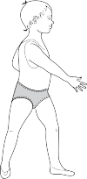

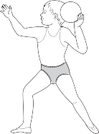
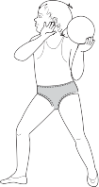
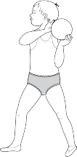
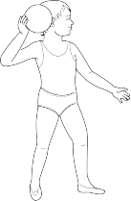
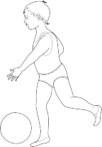
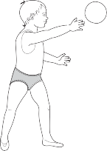
Figure 12.2 (continued).

Orthopedic aspects and common postural disorders in early childhood: diagnosis, prevention, and treatment

The development of disorders in the lower extremities is quite common in early childhood (see also Ch. 5). These disorders may develop as the result of an inborn defect, genetic factors or environmental factors (movement habits, motor deﬁciencies, etc.)
In all cases of a suspected disorder, children should be taken for diagnosis, because aside from postural problems, disorders in the lower extremities may also develop into motor gaps at a later age and impair overall functioning.
Regarding the lower extremities, special attention should be paid to the following:

  - The foot (ankle joint balance and arch development)
  - The knee joint (genu recurvatum, genu valgum/varum, tibial torsion)
  - The hip joint – functional balance on the transverse plane in internal/ external rotation movements.
(Detailed explanations of these disorders appear in Ch. 5.)

Postural characteristics of the feet in early childhood

The structure of the feet changes gradually as children grow. This is an important fact to take into account when diagnosing and treating children, because a child’s age has a direct effect on how his or her feet function. In many cases, what is considered normal for a certain age is deﬁned as a disorder at a later age (Gould & Davies, 1985).
In this context, one of the prominent characteristics of early childhood is low foot arches. This is normal for this age, since the arches continue to develop in later years. At the same time, children should be encouraged to exercise barefoot when possible and should have optimal conditions for foot growth (walking on toes, walking barefoot on sand, grass, carpets, mats, etc.). (Other examples for ways to strengthen foot arches are detailed in Ch. 8.)

Postural characteristics of the knee joints in early childhood

  - Horizontal rotation of the tibia (tibial torsion) – in children, toeing- in may be the result of internal rotation of the tibia in relation to the femur (see also Ch. 5). Tibial torsion may also cause a toeing- out (depending on the rotational direction of the tibia) (Fig. 12.3).
In these cases, it is important to obtain an orthopedic medical diagnosis, and on the basis of the data, to decide whether therapeutic intervention is warranted. In certain cases, joint positions may improve and even correct themselves spontaneously during the growth processes, and in other situations, medical intervention will be recommended.

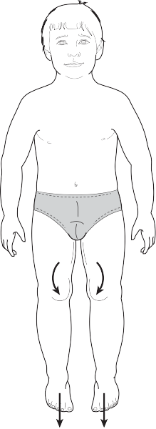


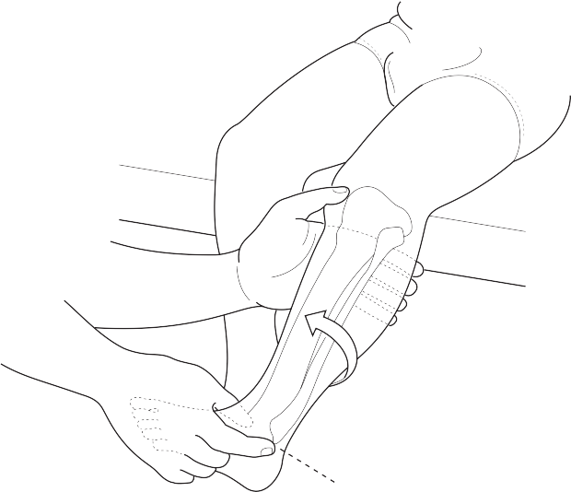
Figure 12.3 Tibial torsion in relation to the femur.

- Genu valgum/genu varum – in early childhood, a number of structural characteristics of the skeletal system affect lower extremity posture. Characteristic postural patterns are reﬂected in genu varum (bowlegs), which in most cases will improve spontaneously as children continue to develop (Kahle et al., 1986).
(Detailed explanation of these issues appears in Ch. 5, Figs 5.7 and 5.8.)

Postural characteristics of the hip joints in early childhood

Several disorders may develop in the hip joint because of a functional imbalance on the horizontal plane in internal–external rotation. Limited range of motion in internal or external hip rotation may cause an imbalance in walking and running, and impair children’s motor functioning (faulty balance, a tendency to fall often, etc.). Aside from the motor implications, disorders of this kind also affect normal anatomical development of the hip joints (Norkin & Levangie, 1993).
Special attention should be paid to children’s sitting habits. One of the common forms of children’s sitting is a “W” position (Fig. 12.4). Although children may ﬁnd this type of sitting comfortable and pleasant, it is not kinesiologically recommended, for the following reasons:

- The position overloads the medial aspect of the knee joints and may weaken the knee ligaments and undermine joint stability

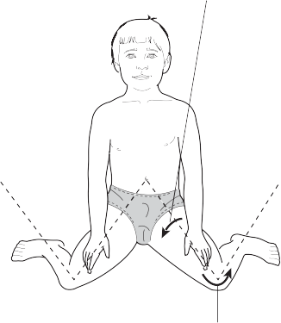
Medial rotation of the hip joint pushes the hip neck forward

Rotation of the knee joint

Figure 12.4 “W” sitting position.

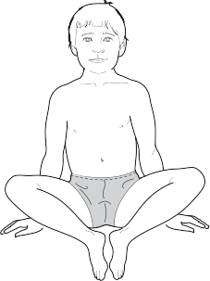

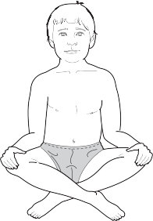
Figure 12.5 Sitting positions that create external hip rotation.

  - Because the torsion angle of the femur tends to be greater in early childhood, this sitting position encourages a pushing forward of
the femoral neck and although comfortable to the child, it prevents natural spontaneous correction (this is explained in greater detail later in this chapter).

This sitting position is especially problematic in conditions of excessive internal hip rotation, as it perpetuates and perhaps exacerbates the problem. Therefore, it is recommended to encourage children to sit in the cross-legged position or with their feet facing each other (Fig. 12.5).
This important change in movement and postural habits may have a positive effect on the normal development of the hip joints as the child undergoes natural growth processes.
When babies remain in a static position for extended periods of time, they can be gently shifted as they sleep. For those children with excessive internal or external rotation of the legs, it is possible to place their legs in proper balance during sleep. Support pillows can be used as needed to prevent legs from moving in an undesirable direction (Fig. 12.6).


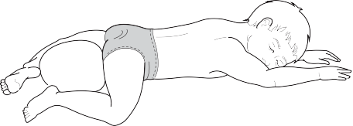


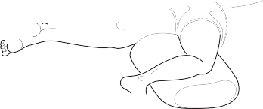
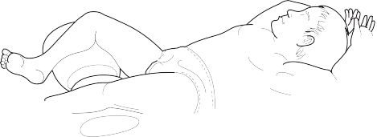
Any change affecting young children’s posture and physical development (including the use of any of the exercises or ideas in this chapter) should be carried out only under the guidance of an orthopedist and after professional diagnosis.

Figure 12.6 The use of support pillows to balance leg position during sleep.

Rotation movement mechanisms of the hip joint

One possible cause of excessive internal or external hip rotation is the anatomical position of the femoral neck in one of these two conditions:

- Anteversion
- Retroversion.
Femur condyles

12°

Under normal conditions (Fig. 12.7), the neck of the femur creates a 12° angle to the line connecting the two femoral condyles. This is the torsion angle of the femur (see also Ch. 5, Fig. 5.10). Any increase in this angle creates a condition called anteversion, which entails excessive internal rotation (Fig. 12.8). Such a condition may cause children to toe-in when they walk.
The reverse situation of anteversion is retroversion, where the torsion angle is <12°. Functionally, the result is excessive external rotation. While walking, the feet toe-out, much like Charlie Chaplin in his movies (Fig. 12.9).
In comparison to adults, young children are usually characterized by heightened anteversion torsion angle. This may explain the high prevalence of toddlers walking with their toes facing in (toe-in).

Summary

Physical maturity and correct instruction by kindergarten teachers, parents or school teachers may help ensure children’s optimal development. An awareness of what constitutes optimal movement and postural development helps to prevent disorders from developing, and to treat them early if they appear.
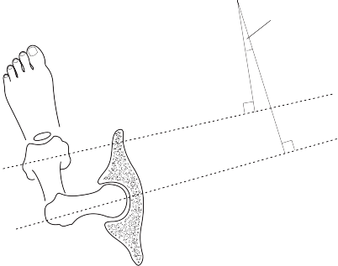
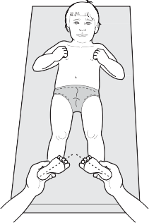
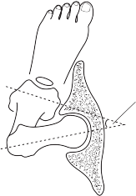
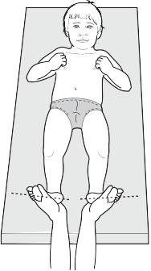
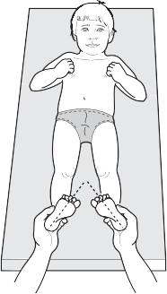
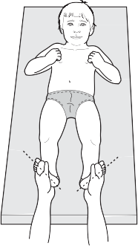
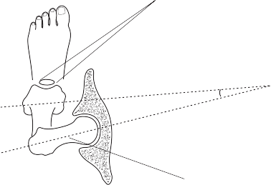
Femur neck

PART THREE
13
Diagnosis and treatment of postural disorders

CHAPTER
Orthopedic support braces for treating children with postural disorders

276 Orthopedic support braces in therapy

279 The importance of combining brace support treatment with adapted
physical activity

279 Summary

After their initial attempts to obtain a reliable diagnosis and determine the appropriate treatment for their children, many parents feel frustrated by the often manifest differences between the opinions expressed by doctors and therapists.
In diagnosing a child with any kind of physical disability, professionals usually express little or no disagreement about the ﬁndings. But in cases of postural disorders, diagnoses can often be contradictory. The reason for these discrepancies lies in the substantial differences in the criteria each professional discipline employs. Thus, a child with minor symptoms of a postural disorder may be diagnosed in one of the following ways:

Option A: Because the disorder is minor, with no pains and no functional limitations,
CHAPTER 13
no treatment is recommended. The condition should simply be monitored periodically.

Option B: The child’s problem may be diagnosed from other aspects, and even if no serious disorder is identiﬁed, treatment may be prescribed to prevent deterioration in the
future, during the child’s physical development (prescriptions include working on body awareness, changing movement and postural habits, and adapted exercise).

Option C: There is no need for speciﬁc movement treatment but swimming is recommended.

Extreme situations may occur in which an ortho- pedist may recommend the use of a brace of some type to treat a given child’s minor postural prob- lem, while another physician may totally dismiss any thought of treatment intervention.
In short, the diagnosis, interpretation of ﬁndings and recommendations offered depend on the pro- fessionals’ subjective approach and their awareness of the side-effects of postural disorders (even if the disorders themselves do not entail serious pathologies).
This problem is often the cause of frustration and helplessness among parents as they deliberate on which approach to adopt. The only way to deal with such a situation is to use one’s common sense and seek both the opinion of a medical expert and comprehensive diagnosis by a certiﬁed therapist with a movement orientation.
Each case must be examined on its own merits. In cases of severe disorders, the option of braces and other support apparatus should not be dismissed, but all cases in which braces are employed should also include adapted physical activity, which may enhance the effectiveness of the orthopedic treatment and reduce the chances of secondary damage caused by the apparatus (muscle weakness, movement rigidity, and affective damage).

Orthopedic support braces in therapy

The principle underlying treatment with orthopedic braces is the creation of mechanical supports that exert pressure on several points on the torso and spinal column.These supports are adapted speciﬁcally to the disorders and to the patient’s physique (Kisner & Colby, 1985).




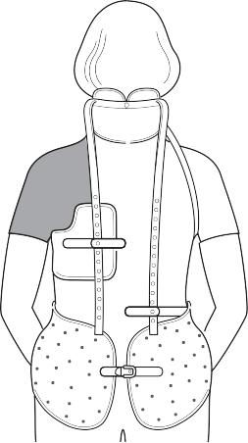
The main purposes of using a brace are to prevent further deterioration of a disorder in the spinal column and to provide general support and stability (mainly during the rapid growth spurt). The disorders in which support braces are used most commonly are idiopathic scoliosis (see Ch. 4), or severe cases of excessive curvatures on the sagittal plane, such as kyphosis or lordosis (see Ch. 3).
Of the various braces available, three are employed most often for treating severe postural disorders – the Milwaukee Brace, the Charleston Brace, and the Boston Brace. Variations on these braces, offering altered brace structure or different material composition, have been developed. The following are the main characteristics of each brace.

The Milwaukee Brace
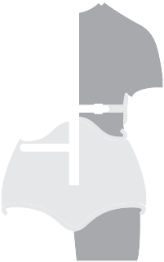

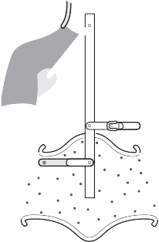

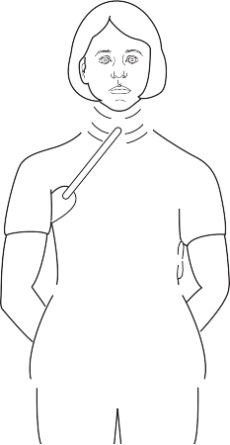
- The Milwaukee Brace (Fig. 13.1A,B) is used for orthopedic treatment of idiopathic scoliosis (see Ch. 4) in severe cases in which there is a fear of deterioration during the rapid growth spurt of adolescence. For this reason, the brace is not usually prescribed for adolescents who are past their growth spurt. At the same time, the brace may be prescribed for children under 10 years in whom severe scoliosis has been diagnosed.
The brace follows the direction of the scoliosis and is attached to the body. It creates support at several points along the spinal column in order to prevent the scoliosis from intensifying and to reduce rotation in the thoracic vertebrae.
The Milwaukee Brace is designed to allow “dynamic correction” of scoliosis in two ways:

  - The brace facilitates correction by providing mechanical supports
- that make children maintain better posture.


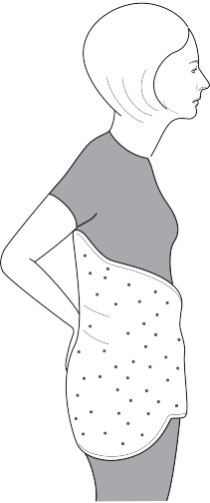
2. Use of the brace also encourages the integration of therapeutic exercise on a daily basis. The exercises are done with and without the brace.

In many cases, patients use the brace for 23 h/day, but exactly how many hours depends on parameters such as disorder severity, child’s age and the attending orthopedist’s approach. The results of studies investigating brace effectiveness and the number of hours per day it should be worn have varied widely (Donaldson, 1981).

C

Figure 13.1 (A,B) The Milwaukee Brace and
  - the Charleston Brace.

Treatment effectiveness using the Milwaukee Brace is controversial, and the results depend on a variety of factors. Certain cases show signiﬁcant improvement, while others manifest progressively worsening conditions of scoliosis despite the brace. Even when spinal alignment has improved, it is possible that once the brace is removed the condition may gradually regress to its previous state.
These ﬁndings are frustrating because the treatment results are not always clear. At the same time, the risk exists that not using the brace will allow the disorder to deteriorate even more. Therefore, it is recommended to weigh all the factors, obtain a number of opinions, and not dismiss the use of the brace out of hand only because of its discomfort.

The Charleston Brace

The Charleston Brace (Fig. 13.1C) was developed for the same con- ditions as the Milwaukee Brace but is more comfortable for children to use. In many cases, the brace is worn only at night when the child is sleeping.

The Boston Brace

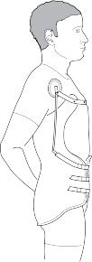
The Boston Brace is used mainly for supporting the torso and does not affect the cervical spine. This brace is most commonly used in case of serious postural disorders in the sagittal plane such as rounded back, kyphosis or lordosis, but in certain cases it is an effective means of support for scoliosis as well.

Main aspects in the use of orthopedic braces


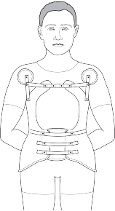
As noted, the use of braces is still controversial, and it is recommended that the decision be made after weighing both the drawbacks and the beneﬁts of such treatment. A later section of this chapter will provide recommendations about when the use of a brace is indicated.

Advantages of using a support brace


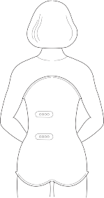
- The brace may provide vital stability for the spinal column. In cases of severe disorders, the brace can help to prevent the condition from deteriorating during the growth spurt by means of mechanical support that prevents the spinal column from collapsing in the direction of the deviation

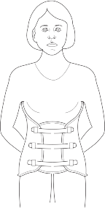
- The brace may help to improve ranges of motion limited by shortened muscles, by means of prolonged mechanical pressure from the brace that may with time stretch the short muscles. In many cases of kyphosis accompanied by a shortening of the pectoral muscles and a pulling forward of the shoulders, the Boston Brace
may be helpful and prevent the shoulders from being pulled forward into scapular protraction (Fig. 13.2).

Figure 13.2 The Boston Brace.

Disadvantages of support braces
  - An uncomfortable period of adjustment. Usually this feeling decreases with time
  - Changes in movement patterns caused by signiﬁcant restrictions on range of torso motion, which affects movement control and the
quality of children's motor performance. Conspicuous examples are new walking patterns children devise as well as new ways of writing and performing other daily functions, such as dressing and eating
  - Limitation of respiratory functioning as a result of pressure on the chest. This pressure may restrict inhalation volume and create shallow, short breathing
  - The brace must be adjusted every few months because of the children's process of growth
  - Prolonged use of support braces may create points of pressure in other parts of the body and limit range of motion. This will be reﬂected in rigid movement patterns and a sensitivity to injury and pains
  - Because the brace creates mechanical support, it may weaken postural muscles by subsuming their function of stabilizing the torso
  - Use of the brace may affect the child's self esteem and social functioning. This depends to a great extent on the child's personality and social status.

When using a brace it is important to remember:
  - Lying down (on one’s back) several times a day may give a feeling of relief and rest
  - Sleeping on a not-overly-ﬁrm mattress may ease discomfort (in cases where a child is supposed to sleep with the brace)
  - It is advisable to adapt clothing to the brace and use wide, lightweight clothing
  - It is advisable to learn and practice breathing exercises to increase ranges of inhalation and exhalation (see Ch. 8). These exercises should be performed without the brace, while lying on the back, making maximal use of chest and rib movement
  - Together with the breathing exercises, it is advisable to perform special exercises for pelvic position, tilting it forward and backward. Such exercise is also important for strengthening the abdominal muscles.





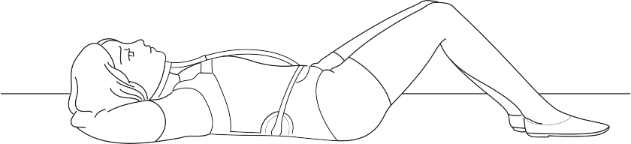
Figure 13.3 Anterior and posterior pelvic tilt as can be done with or without the brace.

The importance of combining brace support treatment with adapted physical activity

Physical activity is an important element of treatment whenever a brace is utilized. Some of the exercises can be performed without the brace and others with the brace on (Fig. 13.3). The main aims of therapeutic exercise in these cases are:

- Maintaining muscle strength throughout the torso because activity declines signiﬁcantly as a result of the ﬁxating support of the brace. This maintenance is especially important for optimal functioning when brace treatment ceases
- Maintaining normal ranges of motion, which is important for the spinal areas ﬁxated as a result of the brace and also for other areas such as the shoulder girdle and the hip joints
- Working on cardiopulmonary endurance by means of activity not entailing shocks and vertical loads on the spine, such as work on stationary bicycles, swimming, etc.
- Improving functional balance between antagonist muscle groups in the torso and along the spinal column. When necessary, asymmetrical exercises especially adapted to the patient's speciﬁc disorder and symptoms should be performed
- General sport activity according to what the children like (swimming, ball games, etc.). Except for activities that are contraindicated (depending on the problem), it is recommended that children be encouraged to participate in sports activities, which may contribute to their physical, social, and emotional
well-being. It is important to remember that movement games and sports serve as important channels of communications for children, and every effort should be made to avoid social isolation caused
by abstention from physical activity. Physical activity has many important ramiﬁcations for the self esteem and physical image that children develop about themselves.

Summary

The effectiveness of treatment with braces and other devices is contro- versial. The approach recommended in this chapter is not extreme in either direction – it does not reject the use of any device outright, nor does it unequivocally advocate its use.
Each case must be examined on its own merits and the decision should be made on the basis of a comprehensive diagnosis that takes the following parameters into account:

- The severity of the disorder
- The child’s emotional state
- Concern about possible worsening of the disorder without use of a brace
- Concern about possible damage as a result of using the brace (emotional problems, damage to self esteem, avoidance of physical activity, weakening of muscles, etc.).

PART THREE
14
Diagnosis and treatment of postural disorders

CHAPTER
Methodological aspects in
the treatment of children with postural disorders

- Aims of treatment in postural disorders

- Selecting the treatment design

- Stages of individual treatment for children with postural disorders
CHAPTER 14

This chapter will discuss a number of methodo– logical aspects of instruction and treatment in dealing with postural disorders. Therapists who understand and implement these aspects will be better equipped to plan their work and choose the most appropriate materials and teaching methods for their patients without clinging to unchanging, rigid exercise patterns.

Aims of treatment in postural disorders

Normal posture, which provides a foundation for optimal body movement, is intrinsically intertwined, as mentioned, with various aspects of human anatomy and physiology. Mechanically speaking, body joints and bones should be aligned for the most efﬁcient bearing of loads resulting from body movement and body weight.
Balanced posture is almost impossible without balance between antagonist muscle groups. Problems there may cause an imbalance in skeletal alignment and over-load joints in the lower extremities, the pelvis or the spine. Therapists must accurately pinpoint the main factors producing the postural disorder and basing themselves on this initial diagnosis, determine the aims of the treatment.

Main treatment aims in postural disorders deal with the following:

  - Maintaining joint mobility and improving functional balance between antagonist muscle groups in order to correct postural disorders on the various planes (such as kyphosis, scoliosis, lordosis, etc.)
  - Improving speciﬁc motor functions that particularly affect posture or are affected by it, such as balance and coordination. One of the aims of treatment is to create the conditions for “natural” body functioning by means of a balanced distribution of energy, where each part of the system functions in coordination with the other parts. This is the actual meaning of normal posture patterns
  - Creating and preserving a new body image – altering wrong habits of movement and posture and learning correct ones. Just as a plant needs water for its roots, not its leaves, mechanically performing one “exercise” or another is not enough. To bring about true change, patients must locate the source of their problem and create change at that speciﬁc point.

Individuals exposed to lessons that integrate therapeutic exercise, experience a variety of movement options that allows them to broaden their movement options and better understand how body limbs interact functionally.
It is extremely important to include postural exercises that help to improve body image. These should include relaxation exercises for reducing excess muscle tone, static and dynamic balance exercises, exercises to improve respiratory functioning, and exercises to develop kinesthetic sense in movement with eyes open and closed.

Selecting the treatment design

Treatment of postural disorders can be given individually or in groups. Each format has its beneﬁts. After the diagnostic stage, therapists should select the optimal treatment by considering the type and severity of the disorder, the child’s personality and the working conditions, such as the type and size of the facility available.
The recommended therapeutic approach usually strives to have children progress and become integrated in group activities. At the same time, coping with signiﬁcant postural disorders often requires a preliminary period of individual activities.

The individual treatment format has a number of advantages

- Better adaptation of the treatment program to the child’s needs.
Individualized treatment allows the therapist to become more familiar with the child’s inner world. In this format, therapists can talk with the child, be attentive to his or her special desires and learn about weaknesses and about those things he or she “loves” or “hates”.
On the physical–postural plane, such familiarity with the child makes adaptation of the exercises to speciﬁc problems more accurate. This is especially important in disorders entailing special asymmetric exercise, such as in treating scoliosis (see Ch. 9, Fig. 9.23)
- The possibility of incorporating treatment techniques involving touch, including methods for strengthening and relaxing muscles, and manipulations that allow passive mobilization of the various joints
- Better monitoring of performance quality of postural exercises the children learn during the treatment
- Easier and better monitoring of children’s progress through periodic tests that check the treatment effect on the disorder.

Stages of individual treatment for children with postural disorders

Individual treatment may include a number of stages, as illustrated in Figure 14.1. For children to derive maximum pleasure and beneﬁt from therapeutic activity, and to maintain a high level of motivation over time, each therapeutic meeting should include three components:

- The learning component – children learn and gradually internalize what is being taught.
- The pleasure and game component – movement games and psychomotor tasks adapted to the problem under treatment (see Ch. 11, Fig. 11.1 for an example).
- The therapeutic component – speciﬁc attention to the patient’s special needs. Here, in addition to speciﬁc exercises, therapists can employ the special tools at their disposal, such as ﬂexibility techniques and touch therapies (massages, passive mobilization, resistance exercises, etc.) (see Ch. 9).

Stage D Specific treatment of the disorder to
improve posture and movement patterns

Stage C
Building the child’s desire
and motivation for starting and continuing treatment (strengthening therapist–patient ties and
adapting treatment techniques to the child’s needs and personality) (selecting activity content and types, utilizing various types of apparatus, adapted feedback, etc.)

Stage B
Setting realistic treatment aims on the basis of diagnostic data

Stage A
Comprehensive diagnosis (posture tests that indicate anthropometric measurements, functional examinations, X-ray analysis and psychomotor tests) (See Ch. 7)

Figure 14.1 Stages of individual treatment for children with postural disorders.

Afterword

In contrast to disciplines with clearly deﬁned and acknowledged boundaries such as physical therapy or occupational therapy, it is hard to ﬁnd one term that encompasses the entire range of interventions detailed in this book. Movement and postural patterns, both in terms of learning processes and of functional aspects, cannot be deﬁned exclusively as the function of physiological processes in the musculoskeletal system. Despite the considerable inﬂuence of various emotional processes on human movement, many of the ties that link parallel neurophysiological and psychological processes are missing. The approach presented in this book emphasizes the integrative nature of many of the components (some of them anatomical–physiological, others behavioral–affective) that affect movement and postural traits. It is little wonder, then, that such an integrative approach is quite naturally applied to a ﬁeld that focuses on adapted physical activity for populations with special needs.
The material presented in this book is based on generally accepted principles in motor development, kinesiology, and biomechanics, but the many ideas and exercises presented here are applied illustrations that therapists are invited to alter, expand on, and deepen. Like any good plan, this book should serve as a basis for change. This approach strives to employ the principles described as the basis for developing additional therapeutic tools. Each exercise presented here can be developed into a more comprehensive movement process, and each motor task cited as an example can be adapted and adjusted to an individual patient’s special needs.
In other words, the spirit of this book encourages the use of what has been done as a basis for developing new ideas and materials: “creating” instead of “buying”, “exporting” instead of “importing”. In this way, we will mutually enrich one another with fascinating materials and a therapeutic approach that encourages ﬂexibility and variety in thought. Chapter 6, which deals with diagnostic approaches, mentions “Maslov’s hammer”. It is my hope that this book will contribute another tool or two to each reader’s personal tool chest.

References

Adams, J. A. (1971) A closed-loop theory of motor learning. Journal of Motor Behavior, 3, 111–149.

Alter, M. J. (1988) Science of Stretching, 1st edn. Illinois: BA Brooks.

Arroyo, J. S., Hershon, S. J. & Bigliani, L. U. (1997) Special considerations in the athletic throwing shoulder. Orthopedic Clinics of North America, 28(1), 69–77.

Baharav, A. (1972) Sport Injuries. Tel Aviv: Niv.

Bak, K. (1996) Nontraumatic glenohumeral instability and coracoacromial impingement in swimmers. Scandinavian Journal of Medicine & Science in Sports, 6, 132–144.

Bak, K. and Faunl, P. (1997) Clinical ﬁndings in competitive swimmers with shoulder pain. The American Journal of Sports Medicine, 25(2), 254–260.

Basmajian, J. V. & Slonecker, C. E. (1989) Method
of Anatomy: A Clinical Problem Solving Approach, 11th edn. Baltimore: Williams & Wilkins.

Basmajian, J. V. (1978) Therapeutic Exercise, 3rd edn. Baltimore: Williams & Wilkins.

Bergman, A. & Hutzler, Y. (1996) Rehabilitation in Water. Ramat Gan: Alef Alef Press.

Brown, L. (1988) An introduction to the treatment and examination of the spine by combined movements. Journal of the Chartered Society of Physiotherapists, 74(7), 347–353.

Buscaglia, L. (1982) Living, Loving and Learning. Tel Aviv: Zamora.

Chia, M. (1993) Iron Shirt Chi Kung. New York: Healing Tao Books.

Chukuka, S., Enwemeka, I., Bonet, M. I., Jayanti,
A. I., Prudhithomrong, S. & Ogbahon, E. F. (1986) Postural correction in persons with neck pain. Journal of Orthopaedic and Sports Physical Therapy, 8(5), 235–238.

Cyriax, J. (1979) Textbook of Orthopaedic Medicine, 7th edn. London: Baillière Tindall and Cassell.

Dennis, M. (1976) Impaired sensory and motor differentiation with corpus callosum agenesis: a lack of callosal inhibition during ontogeny. Neuropsychologia, 14(4), 456–469.
Donaldson, W. F. (1981) Scoliosis. In: A.B. Ferguson, ed. Orthopedic Surgery in Infancy and Childhood, 5th edn. Baltimore: Williams and Wilkins.

Enoka R. M. (1994) Neuromechanical Basis of Kinesiology, 2nd edn. Champaign, IL: Human Kinetics.

Fuchs, Z., Ben-Sira, D. & Zaichkovsky, L. (1985) Selected Issues in Motor Learning, Part 2:
Psycho-neurological and Developmental Aspects. Netanya: Wingate Institute, Gil Publishers.

Geissele, M. E., Kransdorf, M. J., Geyer, C. A.,
Jelinwk, J. S. & Van Dam, B. E. (1991) Idiopathic scoliosis and asymmetry of form and function. Spine, 16(7): 761–763.

Glousman, R. (1993) Electromyographic analysis and its role in the athletic shoulder. Clinical Orthopaedics and Related Research, 288, 27–34.

Gould, J. A. & Davies, G. J. (1985) Orthopaedic and Sports Physical Therapy, Vol. 2. Princeton:
C.V. Mosby.

Gur, V. (1998a) The Posture Cultivation Department
– Handbook for third and fourth year students in the department. The Zinman College of Physical
Education and Sport Sciences at the Wingate Institute.

Gur, V. (1998b). Muscle stretches: The anatomy and biomechanics of connective tissues. Physical Education and Sport, 7, 5–9.

Gur, V. (1998c) The neurophysiology of muscle stretching – Theoretical background and accepted techniques. Physical Education and Sport, 2, 11–16.

Gur, V. (1999a) Issues in ﬂexibility. Physical Education and Sport, 3, 10–14.

Gur, V. (1999b) The hamstrings: characteristics and methods of lengthening them. Physical Education and Sport, 6, 8–14.

Hales, T. R. & Bernard, B. P. (1996) Epidemiology of work related musculoskeletal disorders. Orthopedic Clinics of North America, 27, 679–709.

Hamilton, N. & Luttgens, K. (2002) Kinesiology: Scientiﬁc Basis of Human Motion, 10th edn. New York, NY: McGraw-Hill.

Heijden, G., Beurskens, A., Dirx, M., Bouter, L. M. & Lindeman, E. (1995) Efﬁcacy of lumbar traction:
A randomized clinical trial. Physiotherapy, 81, 29–35.

Hess, S. A. (2000) Functional stability of the glenohumeral joint. Manual Therapy, 5(2), 63–71.

Holon Center for Therapeutic Sport (2000) A Diagnostic Model: Exercises for Evaluating a Child’s Functional Ability in Therapeutic Sport. Holon: Solberg.

Hoppenfeld, S. (1976) Physical Examination of the Spine and Extremities. New York, NY: Prentice Hall.

Hutzler, Y. (1990) Psychomotorics in education and rehabilitation. Physical Education and Sport, 6, 5–7.

Kahle, W., Leonhardt, H. & Platzer, W. (1986) Locomotor System, Color Atlas/Text of Human Anatomy, Vol. 1. New York: Thieme Verlag.

Kamkar, A., Irrgang, J. J. & Whitney, S. L. (1993) Nonoperative management of secondary shoulder impingement syndrome. Journal of Orthopaedic and Sports Physical Therapy, 17(5), 212–224.

Keim, H. R. (1982) The Adolescent Spine, 1st edn. New York: Springer Verlag.

Kendall, F. & McCreary, E. K. (1983) Muscles: testing and function, 3rd edn. Baltimore: Williams and Wilkins.

Kephart, N. C. (1960) The Slow Learner in the Classroom. Columbus, OH: Merrill.

Kibler, W. B. (1998) The role of the scapula in athletic shoulder function. American Journal of Sports Medicine, 26(2), 325–337.

Kibler, W. B., Uhl, T. L. & Maddux, J. W. (2002) Qualitative clinical evaluation of scapular dysfunction: a reliability study. Journal of Shoulder and Elbow Surgery, 11(6), 550–556.

Kisner, C. & Colby, L. A. (1985) Therapeutic Exercise, 2nd edn. Philadelphia: F. A. Davis.

Lippitt, S. & Matsen, F. (1993) Mechanisms of glenohumeral joint stability. Clinical Orthopaedics and Related Research, 291, 20–28.

Loncar-Dusek, M., Pecina, M. & Preberg, Z. (1991) A longitudinal study of growth velocity and development of secondary gender characteristics versus onset of idiopathic scoliosis. Clinical
Orthopaedics and Related Research, 270(1), 278–282.

Ludewig, P. M. & Cook, T. M. (2000) Alterations in shoulder kinematics and associated muscle activity in people with symptoms of shoulder impingement. Physical Therapy, 80(3), 276–291.

McQuade, K. J., Dawson, J. & Smidt, G. L. (1998). Scapulothoracic muscle fatigue associated with alterations in scapulohumeral rhythm kinematics
during maximum resistive shoulder elevation. Journal of Orthopaedic and Sports Physical Therapy, 28(2), 74–80.

Mitrany, R. (1993) Sport Injuries: Diagnosis, Treatment and Prevention of Physical Injuries as a
Result of Athletic Activity. Netanya: Wingate Institute, Gil Publishers.

Nachemson, A. (1983) The load on the lumbar disks in different positions of the body. Clinics in Orthopedics, 45, 107–122.

Nicolopoulus, K. S., Burwell, R. G. & Webb, J. K. (1985) Stature and its component in adolescent idiopathic scoliosis: Cephalo-caudal disproportion in the trunk of girls. Journal of Bone and Joint Surgery, 67(13), 594–601.

Nordin, M. & Frankel, V. H. (1989) Basic Biomechanics of the Musculoskeletal System, 2nd edn. Philadelphia: Lea & Febiger.

Norkin, C. & Levangie, P. (1993) Joint Structure and Function: A Comprehensive Analysis. Philadelphia:
F. A. Davis.

Nudelman, W. & Reis, N. D. (1990) Anatomy of the extrinsic spinal muscles related to the deformity of scoliosis. Acta Anatomica, 139(3), 220–225.

Nudelman, W. & Reis, N. D. (1990) Anatomy of the extrinsic spinal muscles related to the deformity of scoliosis. Acta Anatomica, 139(3), 220–225.

Rasch, P. S. (1989) Kinesiology and Applied Anatomy, 7th edn. Philadelphia: Lea & Febiger.

Ratzon, M. (1993) Perceptual Motor Development and Learning Processes. Tel Aviv: Seminar Hakibbutzim Press.

Ratzon, M. (1993) Perceptual Motor Development and Learning Processes. Tel Aviv: Seminar Hakibbutzim Press.

Ratzon, M. (1993). Perceptual Motor Development and Learning Processes. Tel Aviv: Seminar Hakibbutzim Press.

Roaf, R. (1978) Posture, 1st edn. London: Academic Press.

Sandor, R. & Brone, S. (2000) Exercising the frozen shoulder. Physician and Sportsmedicine, 28(9), 83–84.

Schmidt, R.A. (1988) Motor Control and Learning: A Behavioral Emphasis. Champaign, IL: Human Kinetics.

Schmitt, L. & Snyder-Mackler, L. (1999) The role of scapular stabilizers in etiology and treatment

of impingement syndrome. Journal of Orthopaedic and Sports Physical Therapy, 29(1), 31–38.

Schroth, C. (1992). Introduction to the three dimensional scoliosis treatment according to Schroth. Physiotherapy, 78(11), 810–815.

Sherington, C. S. (1906) The Integrative Action of the Nervous System. Cambridge: Saunders.

Snir, D. (1996) Medical aspects of hydrotherapy. In: A. Bergman & Y. Hutzler, eds., Rehabilitation in Water. Ramat Gan: Alef Alef Press.

Solberg, G. (1994) Diagnosing scoliosis. Physical Education and Sport, 1, 5–7.

Solberg, G. (1995) Activity in the water as therapy for postural disorders. Physical Education and Sport, 5, 11–14.

Solberg, G. (1996a). Plastic changes in spinal function of pre-pubescent scoliotic children engaged in
an exercise therapy program. South African Journal of Physiotherapy, 52(1), 19–22.

Solberg, G. (1996b) Posture Cultivation and Therapeutic Exercise: Handbook for Teachers and Therapists. Tel Aviv: Solberg.

Solberg, G. (1998a) Comprehensive psychomotor diagnosis for populations with special needs (Part I). Physical Education and Sport, 1, 10–13.

Solberg, G. (1998b) Comprehensive psychomotor diagnosis for populations with special needs (Part II). Physical Education and Sport, 2, 25–28.

Solberg, G. (1999) Comprehensive psychomotor diagnosis for populations with special needs (Part III). Physical Education and Sport, 3, 32–34.

Spirduso, W. W. (1978) Hemispheric lateralization and orientation in compensatory and voluntary movement, In: G. E. Stelmach, ed. Information Processing in Motor Control and Learning.
New York: Academic Press.

Steindler, A. (1970) Kinesiology of the Human Body Under Normal and Pathological Conditions, 2nd edn. Springﬁeld: Charles C. Thomas.

Stokes, I. A. & Gardner, M. M. (1991) Analysis of the interaction between vertebral lateral deviation
and axial rotation in scoliosis. Journal of Biomechanics, 24(8), 753–759.

Stone, B., Beekman, C., Hall, V., Guess, V. & Brooks, L. (1979) The effect of an exercise program on change in curve in adolescents with minimal idiopathic scoliosis, Physical Therapy, 59(6), 759–763.
Swarts, L. (1978) Role of kinaesthesia in arousal and learning behavior. Perceptual and Motor Skills, 47, 1219–1225.

Taylor, D. C. & Arciero, R. A. (1997) Pathologic changes associated with shoulder dislocations: arthroscopic and physical examination ﬁndings in ﬁrst-time, traumatic anterior dislocations. American Journal
of Sports Medicine, 25(3), 306–311.

Taylor, J. R. (1983). Scoliosis and growth:
Patterns of asymmetry in normal vertebral growth. Acta Orthopaedica Scandinavica, 54(1), 596–602.

Thein, L. A. & Greenﬁeld, B. H. (1997) Impingement syndrome and impingement-related instability.
In R. A. Donatelli, ed. Physical Therapy of the Shoulder, 3rd edn., pp. 240–254. New York: Churchill Livingstone.

Tyler, T. F., Nicholas, S. J. & Roy, T. (2000) Quantiﬁcation of posterior capsule tightness and motion loss in patients with shoulder impingement. American Journal of Sports Medicine, 28(5), 668–673.

Waddell, G. (1996) Low back pain: A twentieth century health care enigma. Spine, 21, 2820–2825.

Wagner, H. (1990). Pelvis tilt and leg length correction. Orthopedische, 19(5), 273–277.

Warner, J. J., Micheli L. J. & Arslanian, L. E. (1990) Patterns of ﬂexibility, laxity and strength in normal shoulders and shoulders with instability and impingement. American Journal of Sports Medicine, 18(4), 366–375.

Warner, J., Micheli, L. J. & Arslanian, L. E. (1992) Scapulothoracic motion in normal shoulders and shoulders with glenohumeral instability and impingement syndrome: a study using Moire topographic analysis. Clinical Orthopaedics, 285, 191–199.

White, S. & Carmeli, A. (1999) Shoulder pains in swimmers. Physical Education and Sport, 5.

Wilk, K. E., Meister K., Andrews, J. R. (2002) Current concepts in the rehabilitation of the overhead throwing athlete. American Journal of Sports Medicine, 30(1), 136–151.

Yakovlev, P. I. & Lencours, A. R. (1967) The myelogenetics cycles of regional maturation of the brain. In: A. Minkowsky, ed. Regional Development of the Brain in Early Life. Oxford: Blackwell.

Yazdi-Ugav, O. (1995) Motor Development and Motor Learning – Normal vs Abnormal: Theoretical and Practical Aspects. Netanya, Israel: Wingate Institute, Emmanuel Gill Publishing.

Bibliography

Amendt, L. E., Ause Ellias, K. L., Eybers, J. L., Wadsworth, C. T., Nielsen, D. H. & Weinstein,
S. L. (1990) Validity and reliability of the scoliometer. Physical Therapy, 70, 108–117.
Anderson, G. B. & Deyo, R. A. (1996) History and examination in patients with herniated discs. Spine, 21, 10–18.
Arad, H. (1993) Work Program for Physical Education Teachers in Special Education. Netanya: Wingate Institute, Gil Publishers.
Arkin, A. M. (1950) The mechanism of rotation in combination with lateral deviation in the normal spine. Journal of Bone and Joint Surgery, 32(A), 180–190.
Astrand, P. (1992) Why exercise? Medicine and Science in Sports and Exercise, 24, 153–162.
Auxter, D., Pyfer, J. & Huettig, C. (1997) Principles and Methods of Adapted Physical Education and
Recreation, 8th edn. St Louis, MO: Mosby-Year Book.
Axelgard, J. & Brown, J. C. (1983) Lateral electrical surface stimulation for the treatment of progressive idiopathic scoliosis. Spine, 8, 242–260.
Bachara, G. H. (1976) Empathy in learning disabled children. Perceptual and Motor Skills, 43, 541–542.
Barlow, W. (1975) The Alexander Principle. London: Arrow Books.
Basmajian, J. V. (1985) Manipulation, Traction, and Massage, 3rd edn. Baltimore: Williams & Wilkins.
Bergman, A. (1996) Swimming for Populations with Special Needs: A Resource Book for Students, Teachers and Coaches. Tel Aviv: Seminar Hakibbutzim Teachers’ College.
Bohannon, R. (1985) Contribution of pelvic and lower limb motion to increase in the angle of passive straight leg raising. Physical Therapy, 65, 4, 474–476.
Broer, M. & Zernicke, R (1979) Efﬁciency of Human Movement, 5th edn. Philadelphia: Saunders Company.
Bunnell, W. P. (1984) An objective criterion for scoliosis screening. Journal of Bone and Joint Surgery, 66, 1381–1387.
Calais-Germain, B. (1993) Anatomy of Movement. Seattle: Eastland Press.
Capasso, G., Maffulli, N. & Testa, V. (1992) The validity and reliability of measurements in spinal deformities: a critical appraisal. Acta Orthopaedica Belgica, 58(2), 126–135.
Connor-Kuntz, F. J., Dummer, G. M. & Paciorek,
M. J. (1995) Physical education and sport participation of children and youth with Spina Biﬁda Myelomeningocele. Adapted Physical Activity Quarterly, 12, 228–238.
Cornbleet, S. (1966) Assessment of hamstrings muscle length in school children. Physical Therapy, 76,
8, 850–855.
Daniels, L. & Worthingham, C. (1980) Muscle Testing: Techniques of Manual Examination. Philadelphia:
W.B. Saunders.
Davis, W. E. & Rizzo, T. (1991) Issues in the classiﬁcation of motor disorders. Adapted Physical Activity Quarterly, 8, 280–304.
Donatell, R. (1987) Abnormal biomechanics of the foot and ankle. Journal of Orthopaedic Sports and Physical Therapy, 9, 11–16.
Dun, John M. (1989) Special Physical Education: Adapted, Individualized, Developmental, 6th edn. Dubuque, Iowa: W.C. Brown.
Farfan, H. (1995) Musculoskeletal system as revealed by mathematical analysis of the lumbar spine. Spine, 20, 1462–1474.
Gajdosik, R. (1992) Inﬂuence of short hamstrings muscles on the pelvis and lumbar spine in standing and during the toe-touch test.
Clinical Biomechanics, 7, 38–42.
Giallonardo, L. (1988) Clinical evaluation of foot and ankle dysfunction. Physical Therapy, 68, 1850–1856.
Gur, V. (1988) “Permitted” and “forbidden” ﬂexibility exercises. Physical Education and Sport, 6, 8–14. Hadler, N. M. (1995) Controversy. Low back school.
Education or exercise? Spine, 20, 1098. Halbertsma, J. & Goeken, L. (1996) Sport stretching:
Effect on passive muscle stiffness of short hamstrings. Archives of Physical Medicine and Rehabilitation, 77, 688–692.
Hutzler, Y. (1995) Movement on Wheelchairs: A Guide for Users and Therapists. Haifa: Achva Publishers.
Hutzler, Y, Raz-Liberman, Z., Lidor,
R. & Liberman, D. (1995) Control and Motor Learning in Physical Education and Sport: Fundamentals, Approaches and Implementation. Netanya: Wingate Institute, Gil Publishers.
Jansma, P. (1994) Special Physical Education: Physical Activity, Sports and Recreation. Englewood Cliffs, N.J.: Prentice Hall.
Kerrigan, C., Deming L. C. & Molden M. K. (1996) Knee recurvatum in gait: a study of associated knee biomechanics. Archives of Physical Medicine and Rehabilitation, 77, 645–650.
Kisner, C. & Colby, L. A. (1985) Therapeutic Exercise, 2nd edn. Philadelphia: F.A. Davis.
Koeslag, J. H. (1993) What is normal?
South African Medical Journal, 83(1), 47–50. Krau, G. (1981) Problems with Children – Signs and
Symptoms of Difﬁculties in Early Childhood. Tel Aviv: Reshaﬁm.
Li, Y. L. & McClure, P. (1996) The effect of hamstrings muscle stretching on standing posture and on lumbar and hip motions during forward bending. Physical Therapy, 76, 8, 836–849.
Manniche, C. & Hesselsoe, G. (1991) Intensive dynamic back exercises for chronic low back pain: a clinical
trial. Pain, 47, 53–56.
McGill, S. (1998) Low back exercises: Evidence for improving exercise regimens. Physical Therapy, 78, 7, 755–764.
Muhugh, E. (1995) The role of aquatic programs in facilities serving children with physical disabilities. Clinical Kinesiology, 48(4), 83–84.
Osternig, L. R., Robertson R. N., Troxel R. K. & Hansen
P. (1990) Differential responses to proprioceptive

neuromuscular facilitation (PNF) stretch techniques. Medicine and Science in Sports and Exercise, 22(1), 106–111.
Prustig, M. (1994) Move, Grow, Learn: Movement Education – A Teacher’s Guide and Set of New Updated Exercises. Tel Aviv: National Center
for Special Education.
Reid, G. (1992) Editorial on theory, exchange and terminology. Adapted Physical Activity Quarterly, 9, 1–4.
Rolf, I. (1977) Structural Integration:
The Re-Creation of the Balanced Human Body. New York, NY: Viking Press.
Rose, G., Welton, E. & Marshall, T. (1984) The diagnosis of ﬂat foot in the child. Journal of Bone and Joint Surgery, 8, 71–78.
Russel, J. P. (1988) Graded Activities for Children with Motor Difﬁculties. Cambridge: Cambridge University Press.
Sacks, O. (1990) The Man Who Mistook His Wife for a Hat. Tel Aviv: Zamora.
Schwarzer, A. C., Aprill, C. N. & Bogduk, N. (1995) The sacroiliac joint in chronic low back pain. Spine, 20, 31–37.
Shahar-Levy, T. (1994) Initial memory aggregates: Mobility as a code of enciphering and revitalizing pre-cognitive memories. Conversations, 8 (3).
Sharan, S. & Sharan, Y. (1981) Learning Disorders and Their Remediation. Tel Aviv: Sifriat Hapoalim.
Sherill, C. (1993) Adapted Physical Activity, Recreation and Sport: Crossdisciplinary and Lifespan, 4th edn. Dubuque, IO: Brown and Benchmark.
Sherington, C. (1906) On the proprioceptive system, especially in its reﬂex aspect, Brain, 29, 467–482. Sherman, A. (1995) Physical Education and Sport for Populations with Special Needs. Netanya: Wingate
Institute, Gil Publishers.
Sherman, A. (1995) Physical Education for the Special Child. Netanya: Wingate Institute, Gil Publishing.
Simpson, S. & Baharav, Y. (1979) Diagnosing and Promoting the Special Child of Kindergarten Age. Tel Aviv: Ahiasaf.
Solberg, G. (1991) Posture cultivation and therapeutic exercise in the Holon Center for Therapeutic Sport. Physical Education and Sport, 1, 17–19.
Solberg, G. (1993) Is there a universal standard for good posture? Physical Education and Sport, 3, 18–19.
Solberg, G. (1994) The effect of therapeutic exercise on scoliosis. Physical Education and Sport, 2, 6–8.
Solberg, G. (1997) Belly-Back – Handbook for Combat Fitness Instructors. Netanya: Ministry of Defense.
Stokes, I. A. (1991) Biomechanical Testing and Scoliosis: In Vivo Methods. Spine, 16(10), 1217–1223.
Van Coppenolle, H., Simons, J., Pierloot, R. Probst,
- & Kanapen, J. (1989) The Louvain Observation scales for objectives in psychomotor therapy. Adapted Physical Activity Quarterly, 6(2), 170–175.
Warner, J. J. P. (1992) Scapulothoracic motion in normal shoulders and shoulders with glenohumeral instability and impingement syndrome. Clinical Orthopaedics and Related Research, 295, 191–199.
Wells, K. (1966) Kinesiology, 4th edn. Philadelphia: Saunders Company.
Williams, P. L. & Warwick, C. L. (1989) Gray’s Anatomy, 37th edn. New York: Churchill Livingstone.
Wynarsky, G. T. & Shultz, A. B. (1991) Optimization of skeletal conﬁguration: Studies of scoliosis correction biomechanics. Journal of Biomechanics, 24(8), 721–732.
Yalom, E. (1991) Love’s Hangman. Tel Aviv: Kineret.

Appendix 1

Diagnostic intake report

Date: First & Surname:

Gender: M / F (circle one)

__
__
__

__
___
__
___
___
__
__
__
__
___
__
__
__
___
___
___
___
___

Address:

Age:
Telephone (Home):
(Work):

Referred by:

CHAPTER 3

General information
Pregnancy: Birth: General development: Senses (sight, hearing, touch sensitivity):

Motor development (developmental stages) Overall motor functioning Diseases – Allergies Pains Medication Physical activity Club activity Additional treatment General information about the problem and its development

Appendix 2

Parameters for emotional reference

Date: Patient’s name:

____________________________________________________

___________________________________________________________________________
____________________________________________________________

__________________________________________________________________

  - Organizing for and coping with a task
  - Social communication
  - Self conﬁdence
  - Frustration threshold
  - Motivation
  - Impulsivity – Aggressiveness
  - Hyperactivity/hypoactivity
  - Emotional expression
  - Self esteem
  - Fears

Appendix 3

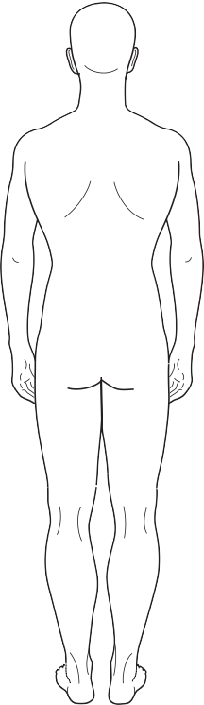
Posture examination form

Date: Name: Surname: Gender: M / F
__
__
___

__
Date of birth:

General Examination

    - Posterior view
      - Achilles tendon and feet: Right
__
__

__
__
__
_____________________
__

__
__
________________________________
_____________________
__________________________________________
__

__

__
__
__

Left

      - Knees (genu varum/genu valgum)

CHAPTER 3
      - Pelvic balance (posterior/superior iliac spine)
      - Scapulae (height, distance from spine, rotation)
      - Shoulder line
      - Neck
      - Symmetry of fat folds (pelvis, waist, neck)
      - Spinal column (scoliosis)

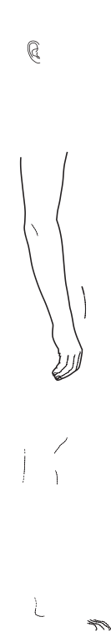
Lateral view
      - Feet arches
      - Knees (hyperextension)
      - Pelvis (posterior/anterior tilt)
      - Spinal curves (kyphosis/lordosis/ﬂat back)
      - Shoulder position
      - Head position (cervical lordosis)

Anterior view
      - Feet
      - Knees
      - Pelvis (anterior superior iliac spine)
      - Shoulders height
      - Neck/Head

Functional tests (Figs 7.1–7.13)
__

__
__
__
___
___
___
__

____________

__

__
__

______________
_______________________________________________________________
_______________________________________________________________

_______________________________________________________________
_______________________________________________________________

_______________________________________________________________
___

_______________________________________________________________
___
- Length of spinal column (C7–S1)

Standing
Forward bending

- General ﬂexibility test Legs straight Forward bending with knees bent

- Hamstrings ﬂexibility (SLR): Right
Left

- Quadratus lumborum ﬂexibility

- Thomas Test for iliopsoas ﬂexibility: Right
Left

- Abdominal muscle strength
- Ability to ﬂatten lower back to ﬂoor (lying supine)

- Range of shoulder motion: Right
Left

- Length of lower extremities: Right
- Back muscle strength: Cervical erectors Erector spinae
Left

Scapulae adductors
- Shoulder girdle strength:

Abduction: Right Adduction: Right
Left Left

Flexion: Right
Left

Extension: Right
Left

- Static balance: Right leg
Left leg

- Dynamic balance
- Forward walking (general evaluation – broad/narrow support base, movement balance, movement ﬂow, coordination)

X-rays, medical documents and previous diagnoses:

General evaluation:

Recommended treatment (indications/contraindications):

Appendix 4

Treatment report and deﬁnition of aims

Date

_________________________
__

ve,

_______________________________________________________________

Child’s name
Age

Activity duration
Disorder treated

Type of activity: Individual/Group/Integrated (circle one)

CHAPTER 3
Location of activity

  - Details of the problems requiring treatment (in reference to the posture and motor tests).
  - Other aspects affecting the child’s condition and the treatment process (reference to family, cogniti emotional and social aspects, level of motivation, cooperation, etc.)
  - Treatment aims and content matter for the coming months: a.
b.
c.
d.

Name of therapist/instructor

Appendix 5

Treatment summary report

Date Child’s name

Age

__
__

__
__
__
__

__
__
__
__

__
__
__
__

__
__
__
__

__
__
__
__

__

Activity duration
Disorder treated

- Entry condition of the child at the beginning of treatment

- Details of treatment goals and work method selected for attaining them

- Child’s condition today (improvement/worsening of condition)

- Recommendations for further treatment of the child

- General comments about treating the child

Name of therapist/instructor

Appendix 6

Self-exercise form

Name
Date

CHAPTER 3

DETAILS OF EXERCISE (DRAWING) NUMBER OF REPETITIONS EMPHASIS FOR PERFORMANCE
1.
2.
3.
4.
5.
6.
7.
8.
9.
10.
11.
12.
13.
14.
15.
16.
17.
18.
19.
20.

GENERAL ASSESSMENT

Appendix 7

Assessment of psychomotor functioning: summary table of diagnostic data
TEST AREA | 1  VERY WEAK | 2  WEAK | 3  MODERATE | 4  GOOD | 5  VERY GOOD | QUALITATIVE ASSESSMENT OF MOVEMENT PATTERNS
A. BASIC SKILLS
Crawling
Walking
Running
Climbing
Jumping on two feet
Hopping on right foot
Hopping on left foot
Skipping
Forward somersault
B. BALL SKILLS
Passing (throwing)
Catching
Bouncing
Shooting
Kicking a soccer ball
Stopping a soccer ball
Shoulder throw with a small ball
C. FINE MOTOR SKILL S
Buttoning
Tying shoelaces
Writing
Control of ﬁngers
D. GENERAL MOTOR A | BILITIES
Static balance on right leg
Static balance on left leg
Dynamic balance
Agility
Speed
General coordination
Eye/hand coordination
Timing
Regulation of force
Reaction time
Movement ﬂow
Crossing midline
General spatial oriention

CHAPTER 3

Assessment of psychomotor functioning: summary table of diagnostic data (continued)
TEST AREA 1 2 3 4 5 QUALITATIVE ASSESSMENT VERY WEAK WEAK MODERATE GOOD VERY GOOD OF MOVEMENT PATTERNS
Personal spatial orientation
Kinesthesis – feeling of movement
E. BEHA VIORAL–EMOTIONAL–COGNITIVE CHARACTERISTICS
Concentration and attention
Cooperation and motivation
General cognitive ability
Language and speech
Self conﬁdence
Self image
Body image
Motor memory
Movement planning
Distinguishing right and left
F. GENERAL EV ALUA TION
G. MAIN EMPHASES FOR TREA TMENT
1.
2.
3.
4.

Index

Note: Page numbers in italics refer to ﬁgures and tables.

Abdominal muscles 52
strength test 177
strengthening exercises 214–215
Abduction 24
arm and scapula 27, 70, 150, 151
coronal/frontal plane movements 28 Acromioclavicular joint 66, 70 Acromion see Scapula
Active stretches 244, 252
Adduction 24
coronal/frontal plane movements 28 Adductor brevis muscle 46
Adductor longus muscle 46 Adductor magnus muscle 46 Adductor minimus muscle 46 Adolescent girls 78, 101
Adolescent growth spurt 101, 108, 109
Aerobic exercises 79
Affect see Emotional factors affecting posture
Age factors
affecting posture 18
see also Children; Developmental aspects Agility and movement speed 194 Alignment exercises 228
use of wall 226–227 Anatomical aspects
ankle joint 34
foot 32
hip joint 44
knee joint 36
pelvis 48–49
rib cage 64, 65
shoulder girdle 66
spinal column 55–59
Anatomical knowledge 23
Ankle joint 34–35
anatomical aspects 34
disorders, contraindicated exercise 248 and foot position during walking
126–127
kinesiological aspects 34
muscles affecting 35
position of medial malleolus and foot arch 32
Antagonistic muscle groups
see under Balance
Anterior pelvic tilt (APT) 27, 53 Anterior superior iliac spine (ASIS) 27
height in scoliosis 103 Anteversion of hip joint 273 Anthropometric measurements 173
in scoliosis 102–103 Arm
abduction–adduction 70 movement in walking 130
and scapula movement 27, 70, 71, 150,
151
and shoulder joint, rotational movements 70, 71, 157–161, 168–169
Associated movements 72 Asymmetrical exercises, scoliosis 110 Asymmetry in scoliosis 101, 102–103,
108, 109
exercises 110
Auxiliary equipment see Exercise equipment
Back exercises
for ﬂat back 86–89
lengthening 204–205, 206–207, 288
strengthening 210–213, 261–262
Balance 183, 186–189
beneﬁts of hydrotherapy 252, 253 between antagonistic muscle groups
20, 30
aim of treatment 282 in kyphosis 78
pelvic position 47, 48, 53
in scoliosis 30, 100, 101
exercises 218–219
in kyphosis 77, 78
in scoliosis 98, 100, 101
tests 187–189
Ball skills 191
and batting skills 144, 145
Behavioral–emotional aspects in diagnosis 196
Biceps brachii muscle 30, 138
Biceps femoris muscle 37, 52
Biomechanical knowledge 22–23
Body awareness see Kinesthesis; Spatial awareness/orientation
Body image 195
aim of treatment 282 beneﬁts of hydrotherapy 252
Boston Brace 277
“Bowlegs” (genu varum) 41, 119, 120, 127,
271
Breaststroke, contraindicated in lordosis 248, 249
Breathing exercises 220–221
for children with orthopedic support braces 278
in kyphosis 79
in scoliosis 110
see also Respiratory system Buoyancy support in hydrotherapy 251
“C” shaped scoliosis 96–97, 110, 111–113
Capsuloligamentous mechanism 135–136 Centre of gravity 77
see also Balance; Support basis Cephalocaudal direction, in early
childhood 266
Cervical erector strength test 177
Cervical lordosis 57, 86 contraindicated exercise
248, 249
Cervical movement planes 57 Charleston Brace 277
Chest muscle lengthening 79 exercises 208–209
Children 264–265
ages 2–4 267
common characteristics 266–269 common postural disorders 270–273 treatment approaches
254–257, 274–279, 80–284
see also Developmental aspects; Diagnosis
Circulatory system 21
Circumduction see Rotational movements Closed kinematic chain exercises 42, 43,
156–157, 251–252
COBB angle 105
“Contact and evasion” exercises 239–240 Coordination 181–182
beneﬁts of hydrotherapy 252, 253
components 182–183
and movement timing tests 184–185 proximal–distal, in early childhood
266–267
in scoliosis 99–100
Coracoacromial arch (CAA) 147–148 Coracobrachialis muscle 69, 138
Coracohumeral impingement 148
Coracohumeral ligament 137 Coronal/frontal plane
disorders 94–113
movements 28
observation 178
Costovertebral joints 63, 65, 153 Crossing the midline tests 190–191 Deep back muscles see Erector spinae
muscle
Deltoid muscle 31, 68, 138
Depression 26
Developmental aspects 18, 19
motor skills 143–144, 266–267
nervous system 72–73
spinal curvature 76, 77 see also Children
Developmental milestones 266
Diagnosis 170–199, 274–275
gait disorders 126–130, 131
parental role 172
posture 173–177
psychomotor 178–197,
198–199, 301–302 appendix
scoliosis 102–105
Diagnostic intake report 294 appendix
Differentiated movement 183
Digestive system 21
Disc herniation 90
Disc protrusion 90
Dorsiﬂexion 25
Drop foot 127
“Duck walk” movement 127–128 Early childhood see Children; Elevation 26
Emotional factors affecting posture 19 beneﬁts of hydrotherapy 253
in kyphosis 78
psychomotor diagnosis 178–197,
198–199, 301–302 appendix
in relaxed posture 91 self-esteem 195–196
Emotional reference parameters 295
appendix
Environmental factors affecting posture 19 Erector spinae muscle 59, 210
strength test 177
Eversion 25
Exercise equipment 264
creative use of 260
“underlying abilities” model 260 “working on the whole” model 261–262
Exercise techniques 200–221
for children with orthopedic support braces 278, 279
hydrotherapy 246–257
special 222–245
see also named disorders

Extension 24
saggital plane movements, 28 Extensor digitorum longus muscle 35 External abdominal oblique muscle 52 External/internal rotation 25
External/lateral rotation 29
“False ribs” 65
Feeling of movement see Kinesthesis Feiss Line 32, 33
Femur
and foot position
(femoral torsion angle) 122, 129–130
and knee joint position 120
see also Hip joint Fibula 34
Fine motor skills 143, 193, 266–267 “First child syndrome” 267
First metatarsal head 32 Flat back, 86–89
Flat foot (pes planus) 116–117 Flexibility
neurophysiological basis for 242 techniques 241–245
test 178
Flexible lordosis 83
Flexible scoliosis 100, 110–113
Flexion 24
saggital plane movements 28 Flexor hallucis brevis muscle 33 “Floating ribs” 65
Foot 32–33
anatomical aspects 32
kinesiological aspects 32
muscles affecting 33
Foot arches 32, 33, 115
disorders 116–117
Foot disorders 116–118 in early childhood 270
Foot exercises 216–217 Foot position
during walking 126–127, 129
femoral torsion angle 122, 129–130
Foot rooting 228
see also Resistance exercises
Free movement in structured framework 235–237
Frozen shoulder 154 Functional tests
muscle/joint range of motion 173
postural examination form 175, 176–177
scoliosis 104
Gait cycle 124–126
pes planus (ﬂat foot) 116 support phase 124, 125, 126
swing phase 125, 126 Gait disorders
common characteristics
131
diagnosis 126–130, 131
Gastrocnemius muscle 35, 38 Gemellus inferior muscle 45 Gemellus superior muscle 45 Gender factors affecting posture 18
in kyphosis 78
in scoliosis 101
Genu valgum (“knock-knees”) 41, 119,
120, 127, 271
Genu varum (“bowlegs”) 41, 119, 120,
127, 271
Genu-recurvatum (hyperextension of knees) 82, 123
Glenohumeral joint 66, 70
Glenohumeral ligaments 137
Glenoid labrum 135
Gluteus maximus muscle 50 Gluteus medius muscle 50 Gluteus minimus muscle 51 Golgi receptors 74
Golgi tendons 242, 243
Gracilis muscle 38, 52
Gross motor skills 192–193, 266–267
Growth spurt, 108, 109
Gym-related shoulder injuries 150 Hamstring ﬂexibility
exercises 79, 244
test (straight leg raising) 178 Hamstring lengthening exercises 202–203 Head
cephalocaudal direction, in early childhood 266
and neck alignment 63 Heredity 18
Hip disorders
in early childhood 271–273 hydrotherapy contraindications and
cautions 248
Hip joint 44–47
anatomical aspects 44
kinesiological aspects 47
muscles affecting 44–46
and pelvis 53
Hip position exercise 228 Hold–relax technique 244 Horizontal plane movements 29 Hormonal control deﬁciencies 101 Humeral head, in shoulder instability
151–152
Hydrotherapy 246–257
adapted activity 250–253 contraindications and cautions 248–249 medical indications 250
program for children 254–257 sports indications 250
Hyperextension of knees
(genu-recurvatum) 82, 123
Iliacus muscle 50
Iliocostalus muscle 60
Iliopsoas muscle (Thomas test) 177 Infraspinatus muscle 68, 139 Integrative approach to posture 16–21 Internal/external rotation 25
Internal/medial rotation 29
Interspinales muscles 61
Intertransversarii muscles 61
Intervertebral discs 58, 86, 87
injuries 90
Inversion 25 Joints
aim of treatment 282 “link system” 224
special characteristics of 31
see also named joints
Kinematic chain exercises hydrotherapy 251–252
knee 42, 43
shoulder 156–157
Kinematic chain principle (chain reaction) 53, 63, 71, 79, 83, 146–147, 155–156
Kinesiological aspects 18–19, 74–75
ankle joint 34
knee joint 39–43
muscular activity 30–31
pelvis 53
therapeutic “link system” 224
see also Scapulothoracic kinesis Kinesthesis 183, 195
in scoliosis 100
Knee disorders 119–121
in early childhood 270–271 exercises
contraindicated 248
kinematic chain 42, 43
see also entries beginning Genu Knee joint 36–43
anatomical aspects 36
kinesiological aspects 39–43
muscles affecting 37–38
Knee ligaments 40
“Knock-knees” (genu valgum) 41, 119,
120, 127, 271
Kyphosis 57, 78–81 position of scapula in 71 possible causes 78, 156 treatment
Boston Brace 277
exercise 79–81
hydrotherapy program 254–257 Lateral ﬂexion
coronal/frontal plane movements 28 measurement in scoliosis 104
Lateral tibia-femoral joint 36 Lateral/external rotation 29 Latissimus dorsi muscle 139 “Leading” exercises 232
Learning component of treatment 284
Levator scapulae muscle 67
Ligaments knee 40
shoulder 135–137
spinal column 58–59
“Link system”, kinesthesiological principle of 224
Longissimus muscle 60
Lordosis 57, 82–85, 86, 87
characteristic signs 82
contraindicated exercise 248, 249
ﬂexible 83
pelvic tilt 48, 49
possible causes 82
structural 83 treatment
Boston Brace 277
exercise 83–85 Lower back see Back
Lower limb length differences 100, 101
measurement 103, 177 Lumbar lordosis see Lordosis Lumbar movement planes 57 Malleolus see Ankle joint Manual guidance in exercises 238 Marfan’s syndrome 248
Medial malleolus and foot arch 32 Medial tibia-femoral joint 36 Metatarsals 32
Midline
crossing tests 190–191 proximal–distal coordination in early
childhood 266–267
Milwaukee Brace 276–277 Motor function
aim of treatment 282
and neurological development 267
in scoliosis 99–100
see also Balance; Coordination Motor outﬂow 72–73
Motor skills
ﬁne 143, 193, 266–267
gross 192–193, 266–267
in shoulder girdle weakness 143–144 Motor stimulation 267, 268–269
Movement 16, 17
planes 28–29
speed 194, 251
terminology 24–27

Multiﬁdus muscles 62
Muscle
activity in posture maintenance 30–31 antagonistic groups see under Balance bundles 30
contraction 31
lengthening 31
origin and insertion of 30 shortening, causes of 241 spindles 242, 243
strengthening effects of hydrotherapy 252
see also named muscles
Myelinization 72
Navicular tuberosity and foot arch 32 Neck
head and, alignment 63
see also entries beginning Cervical Nervous system 21, 72–73
development and motor function 267 receptors 74–75
Neuromuscular functioning
see Balance; Coordination Neurophysiological basis for ﬂexibility
242–243
Obturator externus muscle 45
Obturator internus muscle 45
Open kinematic chain exercises 42, 43,
157, 251–252
Optimal activity for internal body systems 21
Optimal load on skeletal system 20 Orthopedic support braces 274–279
advantages 277
combined with exercise 279 disadvantages 278
important points to remember 278 purpose of 276
types 276–277
Osteoarthritis of shoulder joint 153 Pacini receptors 74
Parental role in diagnosis 172 Passive stretches 244, 252 Patella in knee movement 39–40 Patella-femoral joint 36
Pectineus muscle 46
Pectoralis major muscle 69, 139
Pectoralis minor muscle 69, 156
“Pelvic angle” 48
Pelvic mobility 53
kinematic chain principle 53, 63, 71, 79,
83, 146–147, 155–156
skip role exercise 225 in walking 130
Pelvic position
asymmetry in scoliosis 101
balance between antagonistic muscle groups 47, 48, 53
Pelvic tilt
anterior (APT) 27, 53
during walking 130, 131
posterior (PPT) 27, 53, 226, 227
Pelvis 48–53
anatomical aspects 48–49 and hip joint 53 kinesiological aspects see
Pelvic mobility muscles affecting 50–52
Peroneus brevis muscle 33 Peroneus longus muscle 33 Peroneus tertius muscle 33
Pes cavus (increased arches) 117 Pes planus (ﬂat foot) 116–117 Pes valgus (pronated foot) 118 Pes varus (supinated foot) 118 Phalanges 32
Physical activity affecting posture 19 Piriformis muscle 45
Plantar ﬂexion 25
Plantaris muscle 35
Pleasure component of treatment 284 hydrotherapy 254
Posterior pelvic tilt (PPT) 27, 53, 226, 227 Postural examination form 174–175,
296–297 appendix
Posture, normal 16, 20–21, 31 Pronated foot (pes valgus) 118 Proprioception see Kinesthesis; Spatial
awareness/orientation Proprioceptive neuromuscular facilitation
(PNF) 244–245
Proprioceptors 242–243
Protraction 26
Proximal–distal coordination 266–267 Psoas major muscle 50
Psoas minor muscle 50
Psychomotor diagnosis 178–197, 198–199,
301–302 appendix
Q angle of knee joint, measurement of 40–42
Quadriceps muscle 40 Quadratus lumborum muscle 52
ﬂexibility test 178
“Raindrops” technique, tension point location 233
Range of motion
beneﬁts of hydrotherapy 251 causes of reduction 241–242 ﬂexibility techniques 241–245
Reciprocal innervation technique 245 Rectus abdominis muscle 52
Rectus femorus muscle 37 Regulation of force 182 Relaxation 79, 234, 244
Relaxed posture 91–93
Resistance exercises 229–231
hydrotherapy 252
Respiratory system 21, 65 effects of hydrotherapy 252 in kyphosis 78
see also Breathing exercises Retraction 26
Retroversion of hip joint 273 Rhomboideus major muscle 67 Rhomboideus minor muscle 67 Rib cage 64–65
Rib hump in scoliosis 102 Rigid scoliosis 101
Rooting ability see Foot rooting; Resistance exercises
Rotation of spine in scoliosis 98, 99, 101,
102
Rotational movements 25, 29
arm/shoulder joint 70, 71, 157–161,
168–169
hip joint 47, 271–273
knee joint 39, 42
pelvis 130
Rotator cuff muscles 62, 67, 137, 139
Rufﬁni receptors 74
“S” shaped scoliosis 97, 98
Sacro-iliac joint 49
Sacrum 49 Saggital plane
disorders 76–93
movements 28
observation 178
Sartorius muscle 38, 51
Scapula 67
anthropometric tests in scoliosis 102–103
and arm movement 27, 70, 71, 150, 151
normal position and movement 140–141 position in kyphosis 71
role in shoulder joint stability 150 and thorax see Scapulothoracic kinesis see also Scoliosis; Wing scapulae
Scapular abduction 27, 70, 150, 151
Scapular adduction 27
(shoulder extensors) strength test 177
Scapulohumeral rhythm 70–71
Scapulothoracic joint 66 Scapulothoracic kinesis
altered (scapulothoracic dyskinesis) 141, 146–147
chain reaction 71
exercises 156–161
Scoliosis 96–101
angle 98
“C” shaped 96–97, 110, 111–113
contraindicated exercise 248
diagnosis 102–105
direction 96–97
ﬂexible (functional) 100, 110–113
functional imbalance 98
functional motor difﬁculties 99–100 imbalance between antagonistic muscle
groups 30, 100, 101
location 98
parameters used in determining 96–101 rotation in spinal vertebrae
98, 99, 101, 102
“S” shaped 97, 98
secondary visual indications 99 structural imbalance 98
structural (rigid) 101
support braces 276–277
therapeutic exercise 106–113
effectiveness 106–107
principles 108–109
sample 110–113
Self esteem, low 195–196
Self-exercise form 300 appendix
Semimembranous muscle 38, 51
Semispinalis muscles 62
Semitendinosus muscle 38, 51
Serratus anterior muscle 68
strengthening exercises 164–166 “Shaking out” technique 234 Shock absorption 76–77, 90
Shoe inserts 117
Shoulder girdle 66–71
anatomical aspects 66
common disorders 140–154
exercises 144–147, 155–169
functional rigidity 153–154
kinesiological aspects 70–71
measurements in scoliosis 103, 104
muscles affecting 67–69, 138–139 range of motion test 177 stabilizing elements 134–139
Shoulder girdle weakness/instability 143–147, 151–152
chain reaction 146–147, 155–156
exercises 144–146, 161–163, 168–169
Shoulder impingement syndrome 147–150, 167
Shoulder joint circumduction 29
dislocation 152
passive and active systems 134 stabilizing elements 135–139
subluxation 152
Sitting position in early childhood 271–272
Skip ropes 252
Social environment 19
Soleus muscle 35

Spatial awareness/orientation 194–195, | Stride frequency 126 | Thorax
252 | Stride length 125 | and spinal column 63
Spinal column 54, 55–63 | Structural lordosis 83 | see also Scapulothoracic kinesis
anatomical aspects 55–59 | Structural scoliosis 101 | Tibia 34, 36, 39
disorders | Subacromial impingement (SAI) 147–148 | Tibial torsion 121, 170–171
coronal/frontal plane 94–113 | Subjective evaluation/observation 173, 180, | Tibialis anterior muscle 35
saggital plane, 76–93 | 181, 197 | Tibialis posterior muscle 33
kinematic chain principle 53, 63, 71, 79, | Subscapularis muscle 69, 139 | Tibio-femoral angle of knee joint 41
83, 146–147, 155–156 | Subtalar joint 116, 117, 118 | Toe walking 127
kinesiological aspects 63 | Supinated foot (pes varus) 118 | Toe-in position 122, 129, 273
ligaments 58–59 | Support basis | Toe-out position 122, 129, 273
muscles affecting 60–62 | and balance 77, 100, 183 | Trapezius muscle 67, 150
and thorax 63 | foot rooting 228 | Treatment report and deﬁnition of aims
see also Back exercises; Intervertebral | width during walking 127–129 | 298 appendix
discs; Vertebrae | Support braces see Orthopedic support | Treatment summary report 299
Spinal curvature (normal) 76–77 | braces | appendix
Spinal length examination 178 | Support pillows 272 | Treatments
Spinal lengthening exercises (traction) | Supraspinatus muscle 68, 139 | for children 254–257, 274–279,
206–207 | tendon inﬂammation 148 | 280–284
Spinal rotation 29 | Swimming | see also Exercise techniques
Spinal stability 210 | -induced shoulder impingement | “Underlying abilities” model 260
Spinalis muscles 61 | syndrome 148–149 | Vastus intermedius muscle 37
Splenius (internal muscles) 60 | see also Hydrotherapy | Vastus lateralis muscle 37
Sports | Symmetrical exercises for scoliosis | Vastus medialis muscle 37
for children with orthopedic support | 110 | Vertebrae
braces 279 | Talus 34 | injury 82, 83, 252
indication for hydrotherapy 250 | Tarsals 32 | pathologies causing kyphosis 78
-related shoulder girdle injuries | Tennis-induced shoulder impingement | rotation in scoliosis 98, 99, 101, 102
148–150, 152 | syndrome 149 | structure 56
Static action of muscles 31 | Tension point location 233 | Walking see Gait cycle; Gait disorders
Static exercises for scoliosis 110 | Tensor fascia lata muscle 51 | Wall, use to align posture 226–227
Sternoclavicular joint 66 | Teres major muscle 69, 139 | Wing scapulae 140–143
Sternocostal joint 65, 153 | Teres minor muscle 69, 139 | exercises 164–166
Sternum 64, 65 | Therapeutic component of treatment | Work environment 19
Stick, use in “contact and evasion” exercises | 284 | “Working on the whole” model 261–262
239–240 | hydrotherapy 254 | Writing difﬁculties 143–144
Straight leg raising (hamstring muscle | Thomas test 177 | X-rays 173
ﬂexibility) test 178 | Thoracic movement planes 57 | in scoliosis (COBB angle) 105

